Intelligent Vehicle Monitoring System Using Automatic Number Plate Recognition


By:

Gozel Ali Khan
11788
Zohaib Abbasi
30398
Rai Bilal Sultan
48402

Supervised by:
Imran Khan

Faculty of Computing
Riphah International University, Islamabad
Fall 2025

A Dissertation Submitted To

Faculty of Computing,
Riphah International University, Islamabad
As a Partial Fulfillment of the Requirement for the Award of the Degree of
Bachelors of Science in Computer Science

Faculty of Computing
Riphah International University, Islamabad

Date: [20-04-2026]

Final Approval

This is to certify that we have read the report submitted by Gozel Ali Khan (11788) , Zohaib Abbasi (30398), Rai Bilal Sultan (48402) for the partial fulfillment of the requirements for the degree of the Bachelors of Science in Computer Science (BSCS). It is our judgment that this report is of sufficient standard to warrant its acceptance by Riphah International University, Islamabad for the degree of Bachelors of Science in Computer Science (BSCS).

Committee:

1 | Imran Khan  (Supervisor)
2 | Dr. Musharaf Ahmed  (Head of Department/chairman)

Declaration

We hereby declare that this document “Intelligent Vehicle Monitoring System Using Automatic Number Plate Recognition” neither as a whole nor as a part has been copied out from any source. It is further declared that we have done this project with the accompanied report entirely on the basis of our personal efforts, under the proficient guidance of our teachers, especially our supervisor Imran Khan. If any part of the system is proved to be copied out from any source or found to be reproduction of any project from anywhere else, we shall stand by the consequences.

___________________________
Gozel Ali Khan
11788

___________________________
Zohaib Abbasi
30398

___________________________
Rai Bilal Sultan
48402

Dedication
We dedicate this project to our families for their unwavering support and encouragement throughout our academic journey. To our parents, thank you for believing in us and providing the love and motivation needed to pursue our dreams. Your sacrifices and endless patience have made this achievement possible. We also extend our heartfelt gratitude to our friends for their constant support and for always being there to lend a helping hand or a listening ear. Your camaraderie has made the challenges of this project more manageable and the successes even sweeter. A special thank you to our supervisor Imran Khan, for his invaluable guidance, insightful feedback, and continuous support. Your expertise and dedication have been instrumental in shaping this project and helping us overcome obstacles along the way. Lastly, we dedicate this work to anyone striving to improve agriculture quality. It is our hope that this project will contribute positively to the field of agriculture and assist those in need of reliable plant disease classification and care. Thank you all for being a part of this journey.
Acknowledgement
First of all, we are obliged to Allah Almighty the Merciful, the Beneficent and the source of all Knowledge, for granting us the courage and knowledge to complete this Project.
We would like to express our deepest gratitude to our supervisor, Sir Imran Khan, for his unwavering support, continuous guidance, and insightful feedback throughout the development of this project. His expertise and dedication have been instrumental in shaping our work and helping us navigate through various challenges. We are also immensely grateful to our families for their unwavering support and understanding during our academic journey. Your love and encouragement have been our driving force and have provided us with the strength to persevere. Additionally, we extend our appreciation to our friends and classmates for their assistance, moral support, and for creating a collaborative and motivating environment that made this project more manageable and enjoyable. Lastly, we acknowledge and thank everyone else who contributed to this project in any way. Your support and contributions have been greatly appreciated. Thank you all for being a part of this journey

___________________________
Gozel Ali Khan
11788

___________________________
Zohaib Abbasi
30398

___________________________
Rai Bilal Sultan
48402

Contents
List of Tables iv
List of Figures v
Chapter 1: Introduction 1
Goals and Objectives 1
Scope of the Project 2
Chapter 2: Literature Review 3
Introduction 3
Background and Problem Elaboration 3
2.1 Detailed Literature Review 4
2.1.1 Definitions 4
2.1.2 Related Research Work 1 5
2.1.3 Related Research Work 2 5
2.1.4 Related Research Work 3 5
2.1.5 Related Research Work 4 6
2.1.6 Related Research Work 5 6
2.1.7 Related Research Work 6 6
2.1.8 Related Research Work 7 7
2.1.9 Related Research Work 8 7
Literature Review Summary Table 7
Research Gap 9
Problem Statement 10
Chapter 3: Requirements and Design 12
3.1 Requirements 13
3.1.1 Functional Requirements 13
3.1.2 Non-Functional Requirements 14
3.1.3 Hardware and Software Requirements 14
3.2 Proposed Methodology 14
3.3 System Architecture 15
3.3.1 Components 15
3.3.2 Data Storage 16
3.4 System Architecture Diagram 16
3.5 Use Cases 17
3.5.1 Descriptive Use Cases: 18
Table 3.1 : Use Case: UC01 – User Login 18
Table 3.2 : Use Case: UC02 – User Signup 19
Table 3.3 : Use Case: UC03 – Submit Complaint 19
Table 3.4 : Use Case: UC04 – Scan Vehicle 19
Table 3.5 : Use Case: UC05 – Manage Complaints 20
Table 3.6 : Use Case: UC06 – Receive Alert 20
Table 3.7 : Use Case: UC07 – View Detection History 21
Table 3.8 : Use Case: UC08 – Manage Alerts 21
3.6 Database Design 22
3.7 System Sequence Diagrams 22
3.8 GUI – Graphical User Interfaces 24
3.8.1 Mobile Application GUI Screens 24
3.8.1.1 Login Screen 24
3.8.1.2 Signup Screen 25
3.8.1.3 Dashboard Screen 26
3.8.1.4 Scan Vehicle Screen 26
3.8.1.5 Vehicle Detection Screen 27
3.8.1.6 Search Complaint Screen 28
3.8.1.7 Submit Complaint Screen 28
3.8.1.8 Vehicle Complaint Screen 29
3.8.1.9 Alert Screen 30
3.8.1.10 Complaint Management Screen 30
3.8.1.11 User Profile Screen 31
3.8.1.12 Logout Screen 32
3.8.2 Web Application GUI Screens 32
3.8.2.1 Login Screen 32
3.8.2.2 Signup Screen 33
3.8.2.3 Dashboard Screen 33
3.8.2.4 Vehicle Complaint Screen 34
3.8.2.5 Submit Complaint Screen 34
3.8.2.6 Search Screen 35
3.8.2.7 Complaint Management Screen 35
3.8.2.8 Scan Vehicle Screen 36
3.8.2.9 Connect with IP Camera Screen 36
3.8.2.10 Profile Screen 37
3.8.2.11 Dark Mode Screen 37
3.8.2.12 Alerts Screen 38
3.8.3 GUI Summary 38
Chapter 4: Implementation and Test Cases 39
Introduction 39
4.1 Implementation 39
4.1.1 Data Acquisition and Preprocessing 40
4.1.2 YOLO-Based Detection and OCR Pipeline 41
4.1.3 Vehicle Detection Module 42
4.1.4 Number Plate Recognition Module 43
4.1.5 Backend Implementation 43
4.1.6 Alert Generation Module 44
4.1.7 System Workflow Architecture 44
4.2 Test Case Design and Description 45
4.3 Test Metrics 46
4.4.1 Precision 47
4.4.2 Recall 47
4.4.3 Intersection over Union (IoU) 48
4.4.4 Mean Average Precision (mAP) 48
4.5 Conclusion 48
Chapter 5: Experimental Results and Analysis 49
Introduction 49
5.1 Experimental Setup 49
5.1.1 Data Sources 49
5.1.2 Tools and Technologies Used 49
5.1.3 Testing Conditions 50
5.3 Experimental Results 50
5.3.1 Model Performance Comparison 50
5.3.2 Visual Results 51
5.4 Result Analysis 54
5.4.1 Overall Performance Evaluation 54
5.4.2 Why exp_70 is Selected as the Best Model 55
5.5 Conclusion 56
Chapter 6: Conclusion and Future Directions 56
6.1 Conclusion 56
6.2 Challenges Faced 57
6.3 Limitations 57
6.4 Future Work 57
References 58

List of Tables
Table 1: Literature Review Summary Table 7
Table 2: Use Case UC01 – User Login 17
Table 3: Use Case UC02 – User Signup 17
Table 4: Use Case UC03 – Submit Complaint 17
Table 5: Use Case UC04 – Scan Vehicle 18
Table 6: Use Case UC05 – Manage Complaints 18
Table 7: Use Case UC06 – Receive Alert 19
Table 8: Use Case UC07 – View Detection History 19
Table 9: Use Case UC08 – Manage Alerts 20
Table 10: Test Case TC-01 – User Login 43
Table 11: Test Case TC-02 – AI Plate Detection 43
Table 12: Test Case TC-03 – Submit Complaint 43
Table 13: Model Performance Comparison 50

List of Figures
Figure 1: Proposed Methodology 13
Figure 2: Class Diagram 15
Figure 3: System Architecture Diagram 15
Figure 4: System Use Case Diagram 16
Figure 5: User Authentication Sequence Diagram 20
Figure 6: Vehicle Detection Flow Diagram 20
Figure 7: Alert Generation Diagram 21
Figure 8: Dashboard & Profile Sequence 21
Figure 9: Mobile Login Screen 23
Figure 10: Mobile Signup Screen 23
Figure 11: Mobile Dashboard Screen 24
Figure 12: Mobile Scan Vehicle Screen 25
Figure 13: Mobile Vehicle Detection Screen 25
Figure 14: Mobile Search Complaint Screen 26
Figure 15: Mobile Submit Complaint Screen 27
Figure 16: Mobile Vehicle Complaint Screen 27
Figure 17: Mobile Alert Screen 28
Figure 18: Mobile Complaint Management Screen 29
Figure 19: Mobile User Profile Screen 29
Figure 20: Mobile Logout Screen 30
Figure 21: Web Login Screen 31
Figure 22: Web Signup Screen 31
Figure 23: Web Dashboard Screen 32
Figure 24: Web Vehicle Complaint Screen 32
Figure 25: Web Submit Complaint Screen 32
Figure 26: Web Search Screen 33
Figure 27: Web Complaint Management Screen 33
Figure 28: Web Scan Vehicle Screen 34
Figure 29: IP Camera Connection Screen 34
Figure 30: Web Profile Screen 35
Figure 31: Web Dark Mode Screen 35
Figure 32: Web Alerts Screen 36
Figure 33: Data Acquisition Pipeline 38
Figure 34: YOLO Architecture Diagram 39
Figure 35: System Workflow Architecture 42
Figure 36: Training Results Graph 50
Figure 37: Precision–Recall Curve 51
Figure 38: F1 Score Curve 51
Figure 39: Confusion Matrix 51
Figure 40: Normalized Confusion Matrix 52

Abstract

The rapid growth of vehicular traffic has increased challenges related to traffic management, public safety, and crime prevention. Traditional vehicle monitoring and manual verification systems are slow, error-prone, and ineffective in handling large-scale surveillance. Although existing Automatic Number Plate Recognition (ANPR) systems can identify license plates, they lack real-time intelligence, predictive capabilities, and effective integration with law enforcement databases.
This project presents an AI-Driven Intelligent Vehicle Monitoring System (IVMS) that automates vehicle detection, license plate recognition, verification, and alert generation. The proposed system utilizes deep learning-based object detection (YOLO) to identify vehicles and number plates from live video streams, followed by OCR techniques to extract license plate text. The recognized vehicle information is verified against centralized databases to identify stolen or suspicious vehicles and generate real-time alerts for law enforcement agencies.
In addition to conventional ANPR, the system incorporates intelligent tracking and predictive analysis to estimate possible vehicle movement and escape routes using historical location data. A web-based dashboard and a mobile application are developed to provide real-time monitoring, alerts, and system control for authorized personnel. The proposed IVMS enhances automation, accuracy, and response time, making it suitable for smart city surveillance, traffic enforcement, and crime prevention. This system demonstrates how artificial intelligence can significantly improve modern vehicle monitoring and public safety operations.

Introduction
The rapid increase in the number of vehicles has created serious challenges in traffic management, road safety, and crime prevention. Law enforcement agencies still rely heavily on manual monitoring methods, which are slow, inefficient, and prone to human error. Criminal activities such as vehicle theft, illegal movement, and traffic violations are increasing, making it difficult to identify suspicious vehicles in real time. Traditional surveillance systems lack automation and intelligence, resulting in delayed responses and ineffective enforcement.
Automatic Number Plate Recognition (ANPR) systems have emerged as a promising solution by utilizing artificial intelligence and computer vision techniques to recognize vehicle license plates. However, most existing ANPR systems are limited to basic number plate recognition and do not provide real-time alerts, predictive tracking, or integration with law enforcement databases. The absence of intelligent decision-making and automated verification reduces their effectiveness in modern smart city environments.
To address these limitations, this project proposes an AI-Driven Intelligent Vehicle Monitoring System (IVMS) that combines deep learning, optical character recognition, and real-time data processing to automatically detect vehicles, recognize number plates, verify vehicle information, and generate alerts for suspicious or stolen vehicles. The system enhances public safety by reducing manual effort, improving accuracy, and enabling faster response by authorities.

Goals and Objectives
The primary goal of this project is to develop an intelligent and automated vehicle monitoring system to assist law enforcement agencies in real-time vehicle surveillance.
The specific objectives of the project are:
- To detect vehicles and number plates from live video streams using deep learning techniques
- To accurately recognize license plate characters using OCR methods
- To verify recognized vehicle numbers against authorized databases
- To generate real-time alerts for stolen or suspicious vehicles
- To provide a web-based dashboard and mobile application for monitoring and alerts
- To reduce manual monitoring effort and improve response time

Scope of the Project

The scope of this project includes the development of an AI-based vehicle monitoring system capable of detecting vehicles, recognizing number plates, and generating alerts in real time. The system is designed for use by law enforcement agencies, traffic authorities, and smart city surveillance environments. It supports live camera feeds, centralized databases, and role-based access through web and mobile platforms. The project focuses on software-based solutions and does not include hardware deployment or nationwide database integration, which can be considered as future enhancements.

Literature Review

Introduction
The literature review is a critical component of any academic project as it provides insight into existing research, technologies, and systems related to the problem domain. This chapter explores previous work conducted in the areas of vehicle monitoring, Automatic Number Plate Recognition (ANPR), intelligent surveillance systems, and real-time alert mechanisms. The purpose of this review is to analyze the strengths and weaknesses of existing approaches and identify research gaps that motivate the development of the proposed Intelligent Vehicle Monitoring System (IVMS).
With the rapid growth of urbanization and vehicular traffic, researchers have increasingly focused on automated and intelligent solutions for traffic management and public safety. Various approaches ranging from traditional image processing to advanced deep learning-based methods have been proposed. However, despite these advancements, many systems still lack real-time intelligence, scalability, predictive capabilities, and seamless integration with law enforcement databases. This chapter systematically reviews these approaches to justify the need for the proposed system.

Background and Problem Elaboration
Vehicle-related crimes such as theft, illegal movement, and traffic violations have increased significantly over the past decade. Conventional traffic monitoring systems rely heavily on manual observation, CCTV surveillance, and human intervention, which are time-consuming, error-prone, and inefficient for large-scale monitoring. These limitations make it difficult for law enforcement agencies to respond promptly to suspicious activities.
Automatic Number Plate Recognition (ANPR) emerged as an automated solution to identify vehicles by extracting license plate information from images or video streams. Early ANPR systems were based on traditional image processing techniques such as edge detection, morphological operations, and template matching combined with Optical Character Recognition (OCR). While these systems performed adequately in controlled environments, they struggled in real-world conditions involving low lighting, weather variations, motion blur, and occluded or damaged plates.
The advent of deep learning and Convolutional Neural Networks (CNNs) significantly improved object detection and recognition accuracy. Modern ANPR systems utilize deep learning models to detect vehicles and license plates more robustly. However, many existing systems still operate as isolated recognition tools without real-time alerting, predictive analysis, or integration with centralized databases. Furthermore, commercial solutions, although accurate, are often expensive and closed-source, limiting their adoption in academic and low-budget environments. These challenges highlight the need for an intelligent, real-time, and cost-effective vehicle monitoring system.

2.1 Detailed Literature Review

Definitions
These are the definition
- Automatic Number Plate Recognition (ANPR): ANPR is a computer vision-based technique used to automatically detect and recognize vehicle license plates from digital images or video streams. It typically involves plate detection, character segmentation, and character recognition.
- Optical Character Recognition (OCR): OCR is a technology that converts text present in images into machine-readable characters. In ANPR systems, OCR is used to extract alphanumeric characters from detected license plates.
- Deep Learning: Deep learning is a subset of machine learning that uses multi-layer neural networks to automatically learn features from data. CNNs are commonly used in image-based tasks such as object detection.
- Intelligent Surveillance Systems: These systems integrate artificial intelligence, real-time data processing, and automation to monitor environments and assist in decision-making processes.

Related Research Work 1
Anagnostopoulos et al. (2008) presented a comprehensive survey of traditional ANPR systems based on image processing and OCR techniques. Their work focused on automatic vehicle identification using steps such as image preprocessing, plate localization, character segmentation, and recognition. The study demonstrated reliable plate recognition in controlled environments with proper lighting and fixed camera angles.
However, the authors highlighted several limitations, including poor performance in adverse weather conditions, sensitivity to illumination changes, and difficulty handling blurred or angled plates. These limitations make traditional ANPR systems unsuitable for real-world, large-scale deployment. The proposed IVMS overcomes these issues by employing deep learning-based detection using YOLOv11, which is more robust to environmental variations.

Related Research Work 2
Silva et al. (2018) proposed a CNN-based object detection framework for vehicle and license plate localization. By leveraging deep learning, their system achieved higher detection accuracy compared to traditional methods. The use of CNNs enabled automatic feature extraction, reducing dependency on handcrafted features.
Despite improved accuracy, the system suffered from high computational complexity, requiring powerful hardware for real-time performance. This limitation restricts its practical deployment, especially in resource-constrained environments. The proposed IVMS addresses this challenge by optimizing YOLOv11 for real-time detection with lower latency and improved efficiency.

Related Research Work 3
OpenALPR is a commercial AI-based ANPR system designed for large-scale vehicle monitoring applications. It provides high accuracy, scalability, and advanced analytics features. OpenALPR has been successfully deployed in developed regions for traffic enforcement and parking management.
However, its closed-source nature and high licensing cost make it unsuitable for academic research and low-budget organizations. Additionally, customization and integration flexibility are limited. The proposed IVMS offers an open-source and cost-effective alternative while maintaining competitive performance for research and educational purposes.

Related Research Work 4
Khan et al. (2020) studied traffic monitoring systems in Pakistan, focusing on manual and semi-automated approaches used by local traffic authorities. Their findings revealed partial automation and limited use of technology, resulting in delayed enforcement and inefficient monitoring.
The system lacked real-time alerts and automated verification against police databases. The proposed IVMS improves upon this work by introducing real-time AI-based detection, automated verification, and instant alert generation to support law enforcement agencies in developing regions.

Related Research Work 5
Traditional OCR-based ANPR systems using tools such as Tesseract focus primarily on character recognition. These systems perform well on clean and high-quality images but fail under noisy conditions, angled plates, and varying fonts.
To address these issues, the proposed IVMS employs a hybrid OCR approach combining EasyOCR and Tesseract. This hybrid strategy improves recognition accuracy by leveraging the strengths of both OCR engines, making the system more robust in real-world scenarios.

Related Research Work 6
Smart city surveillance systems typically rely on CCTV-based monitoring to observe urban environments and support crime prevention. While effective for visual monitoring, these systems lack intelligent analysis, predictive tracking, and automated decision-making.
The proposed IVMS extends traditional surveillance by incorporating intelligent vehicle tracking and route prediction using historical location data and mapping services. This enables proactive policing and improved response planning.

Related Research Work 7
Existing police databases generally maintain static records of stolen vehicles. Verification is often performed manually, which delays response time and reduces operational efficiency.
The proposed IVMS integrates dual databases and live verification mechanisms to automate the validation process. This integration significantly improves response time and reduces reliance on manual checks.

Related Research Work 8
Rule-based alert systems generate notifications based on predefined thresholds. While simple to implement, these systems often result in delayed or ineffective responses.
The proposed IVMS introduces a multi-channel alert system that delivers notifications through dashboards and email, ensuring timely and effective communication with authorities.

Literature Review Summary Table
The columns in the table depend upon your problem and should be specific to your project.

Table 1: History of Computing Devices
The summary of various computing devices invented in the past from 1833-1901 is presented here.
No. | Name / Reference | Approach | Challenges Addressed | Results | Limitations / Future Work | Our Proposed IVMS
1 | Anagnostopoulos et al., 2008 (ANPR Survey) | Image Processing + OCR | Automatic vehicle identification | Reliable plate recognition in controlled environments | Poor performance in bad weather and low light | Uses YOLOv11 for robust detection in real-world conditions
2 | Silva et al., 2018 (CNN-based Vehicle Detection) | CNN-based Object Detection | Vehicle and number plate localization | Improved detection accuracy | High computational cost, limited real-time use | Optimized YOLOv11 for real-time vehicle and plate detection
3 | OpenALPR System (Commercial) | Proprietary AI-based ANPR | Large-scale vehicle monitoring | High accuracy in developed regions | Expensive, closed-source, limited customization | Open-source, low-cost academic solution
4 | Khan et al., 2020 (Pakistan Traffic Monitoring) | Manual + Semi-automated Systems | Traffic law enforcement | Partial automation achieved | No real-time alerts or intelligent verification | Real-time alerts with automated database verification
5 | Tesseract OCR-based ANPR | Traditional OCR | Plate character recognition | Works well for clean images | Fails under noise, blur, and angled plates | Hybrid OCR using EasyOCR + Tesseract
6 | Smart City Surveillance Systems | CCTV-based Monitoring | Urban vehicle surveillance | Crime monitoring support | No predictive analysis or tracking | Route prediction using map-based APIs
7 | Existing Police Databases | Static Stolen Vehicle Records | Vehicle record management | Manual verification | No live or automated validation | Dual database with live police record verification
8 | Rule-Based Alert Systems | Threshold-based Alerts | Crime notification | Basic alert generation | Slow response, limited intelligence | Multi-channel alerts (Dashboard, Email, Mobile App)

Research Gap
The review of existing literature and related systems reveals several critical gaps in current vehicle monitoring and Automatic Number Plate Recognition (ANPR) solutions. Although significant advancements have been made in vehicle detection and license plate recognition, most existing systems focus only on identification rather than intelligent decision support. Traditional ANPR systems primarily rely on image processing and OCR techniques, which perform well under controlled conditions but fail in real-world environments involving poor lighting, weather variations, motion blur, and partially occluded plates.
Deep learning-based approaches have improved detection accuracy; however, many proposed systems suffer from high computational complexity and are not optimized for real-time deployment. Furthermore, several research studies and commercial systems operate as standalone solutions without real-time integration with law enforcement or police databases. This lack of automated verification results in delayed responses and continued dependence on manual checking.
Another major research gap is the absence of predictive intelligence in existing vehicle monitoring systems. Most solutions are reactive in nature, generating alerts only after a vehicle has been detected. Very limited research addresses vehicle movement analysis, route prediction, or escape path estimation, which are crucial for proactive law enforcement and crime prevention.
Additionally, existing alert mechanisms are often rule-based and single-channel, leading to slow response times and reduced effectiveness. There is also a lack of open-source, cost-effective solutions suitable for academic research and deployment in developing regions. Many commercial systems are expensive, closed-source, and difficult to customize.
Therefore, there is a clear need for an intelligent, real-time, and cost-effective vehicle monitoring system that not only detects and recognizes vehicles but also integrates automated database verification, multi-channel alerting, and predictive tracking. The proposed Intelligent Vehicle Monitoring System (IVMS) aims to bridge these research gaps by combining deep learning-based detection, hybrid OCR, real-time alerts, and predictive analysis into a unified and scalable framework.

Problem Statement

The rapid increase in vehicular traffic has significantly intensified challenges related to traffic management, vehicle theft, and public safety. Law enforcement agencies still rely heavily on manual monitoring and traditional surveillance systems, which are inefficient, time-consuming, and prone to human error. These methods are unable to handle large-scale, real-time vehicle monitoring required in modern urban environments.
Although Automatic Number Plate Recognition (ANPR) systems have been introduced to automate vehicle identification, most existing solutions are limited to basic license plate recognition. They lack real-time intelligence, automated verification with police databases, and predictive capabilities for vehicle tracking. Furthermore, traditional OCR-based systems perform poorly under real-world conditions such as low lighting, adverse weather, motion blur, and partially occluded or damaged number plates.
Deep learning-based approaches have improved detection accuracy; however, many of these systems are computationally expensive, not optimized for real-time deployment, and operate as standalone solutions without integration into law enforcement workflows. Additionally, existing alert mechanisms are often rule-based and reactive, resulting in delayed responses and reduced effectiveness in preventing vehicle-related crimes.
Therefore, there is a critical need for an intelligent, automated, and real-time vehicle monitoring system that not only detects and recognizes vehicles accurately but also verifies vehicle information against centralized databases, generates timely alerts, and supports predictive tracking to assist law enforcement agencies in proactive decision-making. The proposed Intelligent Vehicle Monitoring System (IVMS) aims to address these limitations by leveraging deep learning, hybrid OCR, real-time alerts, and intelligent analytics within a unified framework.

Requirements and Design
This chapter describes the detailed requirements and design of the proposed Intelligent Vehicle Monitoring System (IVMS). It explains the functional and non-functional requirements, hardware and software specifications, proposed methodology, system architecture, and use cases. The purpose of this chapter is to provide a clear understanding of how the system is designed and how each component works together to achieve the project objectives. The information presented in this chapter enables readers to understand, implement, and reproduce the proposed system.

3.1 Requirements
IVMS is developed as a multi-platform system that integrates on-device camera scanning with real-time backend AI processing and alert generation. The system leverages deep learning for automated vehicle and plate detection and utilizes a centralized complaint database for verification. To ensure optimal functionality, reliability, and scalability, the system requirements are classified into three categories: functional requirements, non-functional requirements, and hardware and software requirements.

3.1.1 Functional Requirements
The functional requirements define the core operations and behaviors of the IVMS system:
- FR1: User Authentication — Users register with full name, email, CNIC, phone, and password and authenticate via JWT-based authentication.
- FR2: Vehicle Scanning — The system allows the user to capture a vehicle image or upload an existing image, which is sent to the backend AI module for processing.
- FR3: License Plate Detection — The system employs a pre-trained YOLOv11 model to detect vehicles and localize license plate regions within the submitted image.
- FR4: Plate Text Recognition — The system applies EasyOCR and Tesseract OCR to extract and normalize alphanumeric text from the detected plate region.
- FR5: Complaint Submission — Authenticated users can submit stolen vehicle complaints including owner information, vehicle make/model/color, license plate number, and chassis number.
- FR6: Database Verification — The system automatically queries the complaint database using the recognized plate number (case-insensitive matching) to identify stolen vehicle matches.
- FR7: Alert Generation — When a plate match is found, the system creates Detection and Alert records, and dispatches notifications via WebSocket and HTML email.
- FR8: Complaint Management — Admin users can view all submitted complaints and update their status to Investigating, Resolved, or Closed.
- FR9: Alert Management — Users can view all received alerts, distinguish read/unread status, and mark individual alerts as read.
- FR10: Detection History — Users and administrators can browse a chronological history of all detection events with plate text, image, and timestamp.

3.1.2 Non-Functional Requirements
- Accuracy: The YOLOv11 model shall achieve at least 88% plate detection accuracy under normal lighting conditions.
- Performance: Vehicle detection and plate recognition shall complete within 1–3 seconds per image submission. WebSocket alerts shall be delivered within 2 seconds.
- Compatibility: The Flutter app shall run on Android devices (version 8.0 and above). The React.js dashboard shall be compatible with modern web browsers.
- Security: All API endpoints shall be protected by JWT authentication. User passwords shall be stored as bcrypt hashes.
- Scalability: The system shall support concurrent access by multiple users through the Django Channels + Redis architecture.

3.1.3 Hardware and Software Requirements
Hardware Requirements: Smartphone with Android 8.0+ and minimum 3 GB RAM; Server with minimum 8 GB RAM and preferably NVIDIA CUDA-enabled GPU for YOLO model inference.
Software Requirements: Flutter SDK, Python 3.10+, Django 4.2+ with Django REST Framework, Ultralytics YOLOv11, EasyOCR, Tesseract, OpenCV, MySQL/PostgreSQL, React.js 18+ with Tailwind CSS.

3.2 Proposed Methodology
The proposed methodology for IVMS integrates image-based vehicle detection with real-time database verification and multi-channel alert dispatch to provide accurate and timely stolen vehicle identification. The main steps are: (1) Data Collection and Preparation, (2) Model Development, (3) Backend Integration, (4) Multi-Platform Application Development, and (5) System Testing and Validation.

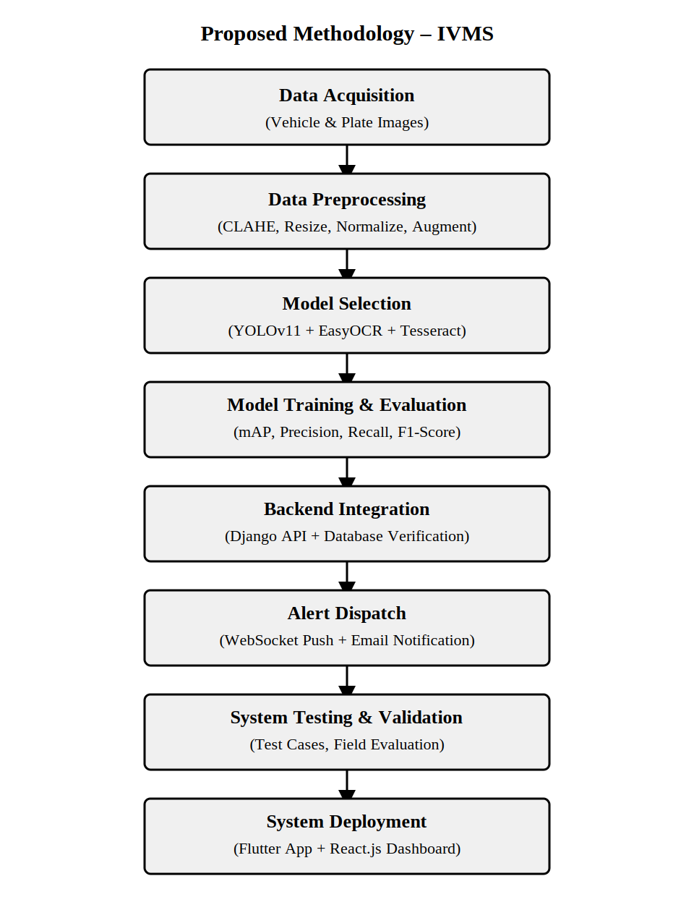
Figure 3.1 : Proposed Methodology

3.3 System Architecture
The IVMS system integrates multiple components to deliver accurate vehicle plate detection, real-time database verification, and instant multi-channel alert dispatch within a user-friendly multi-platform application.

3.3.1 Components
- User Interface (Mobile App): Built with Flutter for cross-platform compatibility. Allows users to capture vehicle images, submit complaints, view alerts, and check detection history.
- AI Detection Module: YOLOv11 model running on the Django backend server. EasyOCR and Tesseract OCR pipeline for extracting plate text from detected plate regions.
- Backend REST API: Django 4.2+ with Django REST Framework for all CRUD operations. JWT-based authentication. MySQL/PostgreSQL database for storing users, complaints, detections, alerts.
- Real-Time Alert Module: Django Channels + Redis for WebSocket server. Post-save signal triggers alert creation and WebSocket push notification upon detection match.
- Web Dashboard: React.js 18 with Tailwind CSS for administrative monitoring. WebSocket client for real-time dashboard updates.

3.3.2 Data Storage
Data storage is used to securely save all application data such as user records, complaint registries, detection histories, and alert logs. MySQL is used during development as a relational database management system. PostgreSQL is the target production database for its advanced indexing and concurrent access capabilities.

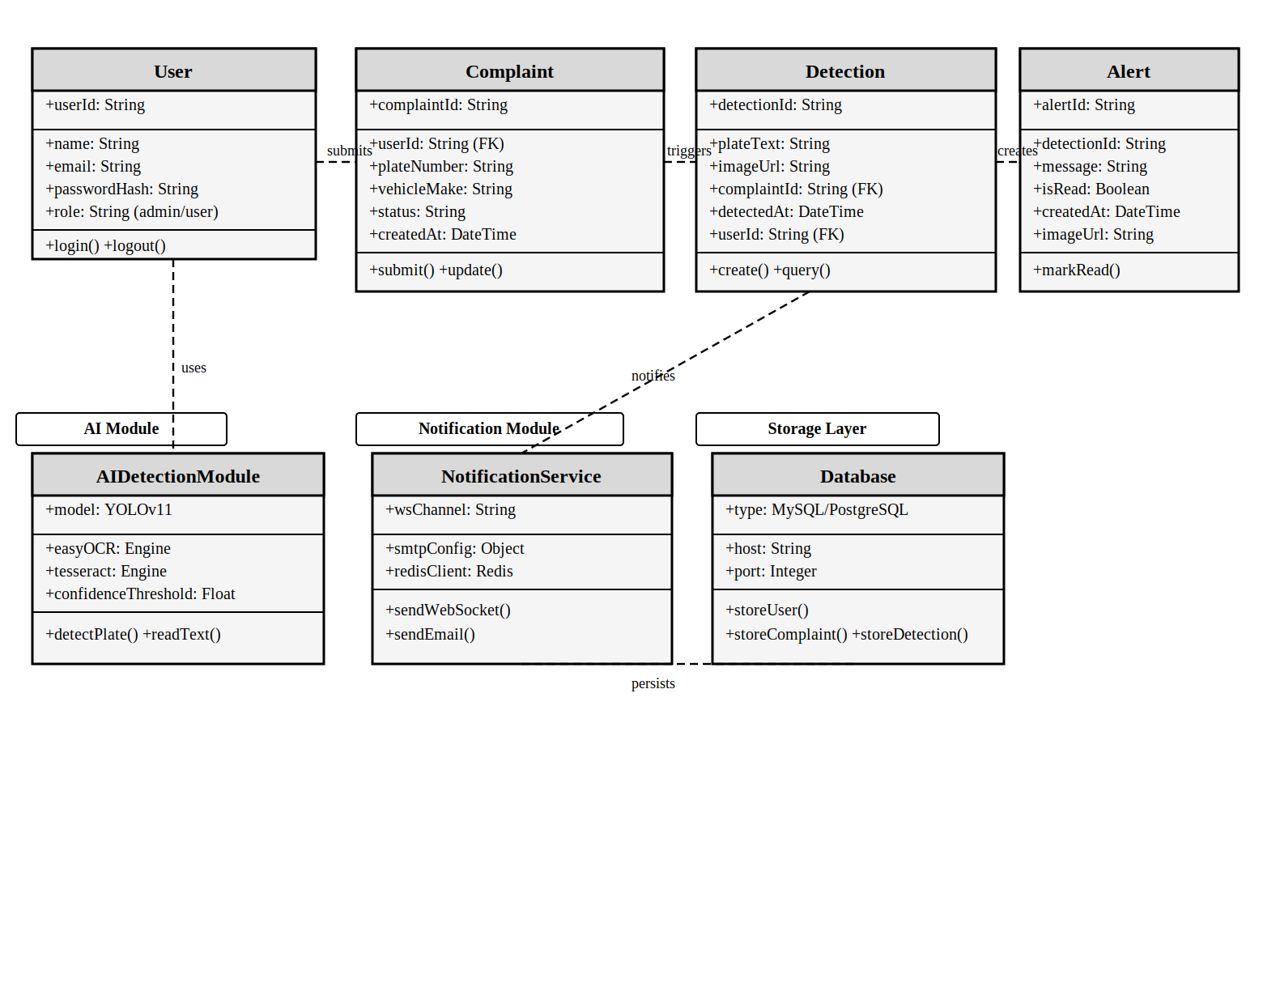
Figure 3.2 : Class Diagram

3.4 System Architecture Diagram
The architecture diagram illustrates how the IVMS system flows from vehicle image capture on the mobile app to backend AI processing (YOLO + OCR), database verification, and real-time alert dispatch. It shows the interaction between the YOLOv11 detection model, OCR pipeline, complaint database, Django Channels WebSocket server, and client interfaces.

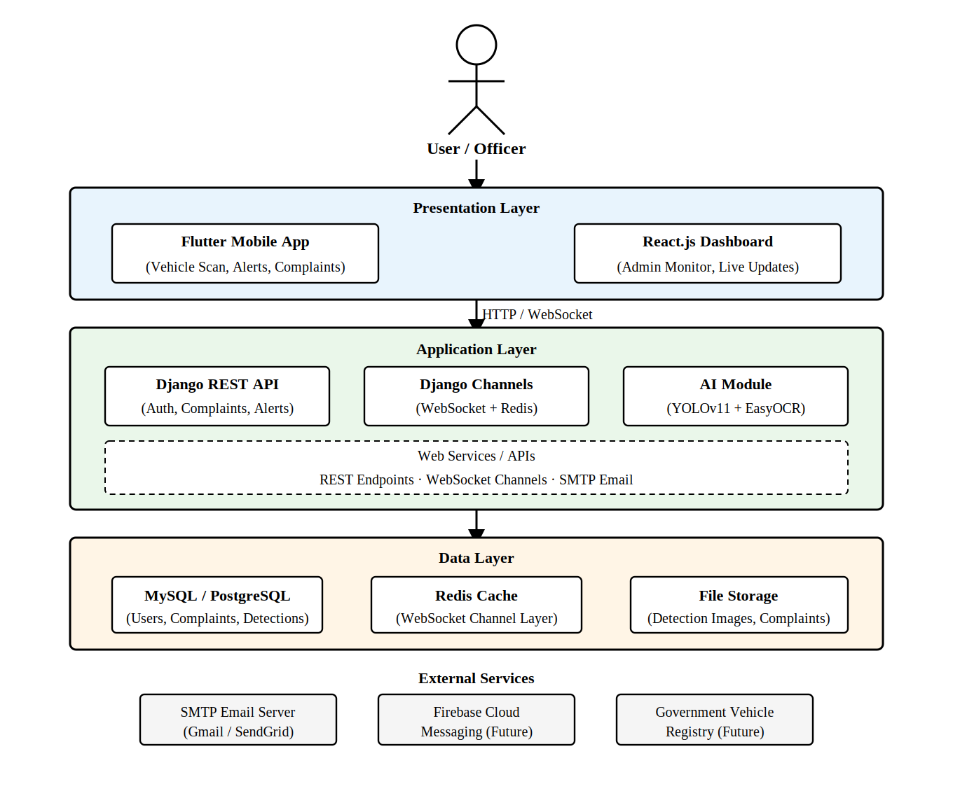
Figure 3.3 : System Architecture Diagram

3.5 Use Cases

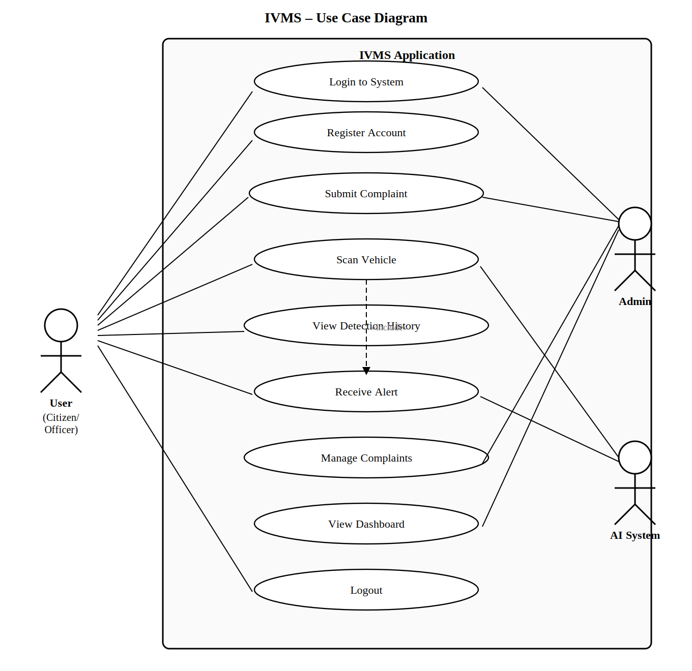
Figure 3.4 : System's Use Case Diagram

3.5.1 Descriptive Use Cases:

Table 3.1 : Use Case: UC01 – User Login
Use Case ID | UC01
Use Case Name | User Login
Primary Actor | User, Admin
Goal | To authenticate and access the IVMS system using registered email and password.
Preconditions | User account must exist in the system. User must not already be logged in.
Postconditions | JWT access and refresh tokens issued. User redirected to role-appropriate dashboard (Admin Dashboard or User Dashboard).
Main Flow | 1. User opens the Login screen. 2. System displays login form. 3. User enters valid email and password. 4. System validates credentials and issues JWT tokens. 5. User is redirected to their dashboard.
Alternative Flow | 3A: User enters invalid email/password → System responds: 'Incorrect email or password.' 3B: Account deactivated → System responds: 'Account suspended. Contact administrator.'

Table 3.2 : Use Case: UC02 – User Signup
Use Case ID | UC02
Use Case Name | User Signup
Primary Actor | User
Goal | To register a new user account to access the IVMS application features.
Preconditions | No prior account with the same email must exist.
Postconditions | A new user account is created. The user can log in to the system.
Main Flow | 1. User opens Sign Up screen. 2. System displays registration form. 3. User enters name, email, CNIC, phone, and password. 4. User submits the form. 5. System validates, creates account, and displays success message.
Alternative Flow | 4A: Incomplete or invalid fields → System shows validation errors on specific fields. 4B: Email already registered → System responds: 'Email already exists.'

Table 3.3 : Use Case: UC03 – Submit Complaint
Use Case ID | UC03
Use Case Name | Submit Complaint
Primary Actor | User
Goal | To register a stolen vehicle complaint with all owner and vehicle details for database tracking.
Preconditions | User must be authenticated and logged in.
Postconditions | Complaint saved with status 'Investigating'. Unique Complaint ID displayed to user.
Main Flow | 1. User navigates to Submit Complaint screen. 2. System displays the complaint form. 3. User fills owner info: name, email, CNIC, phone. 4. User fills vehicle info: make, model, color, plate number, chassis number. 5. User optionally uploads vehicle photo and writes description. 6. User taps Submit. 7. System validates, saves complaint, displays confirmation with Complaint ID.
Alternative Flow | 6A: Required fields empty/invalid → System shows field-level errors. 6B: Plate already in active complaint → System notifies: 'Duplicate complaint detected.'

Table 3.4 : Use Case: UC04 – Scan Vehicle
Use Case ID | UC04
Use Case Name | Scan Vehicle
Primary Actor | User, AI System
Goal | To capture a vehicle image, detect its license plate, cross-check with complaint database, and generate alert if stolen vehicle is identified.
Preconditions | User must be logged in. Camera permission granted. AI module (YOLOv11 + EasyOCR) must be operational on backend server.
Postconditions | A Detection record is created. If match found: Alert record created, WebSocket notification sent, HTML email dispatched.
Main Flow | 1. User opens Camera/Scan screen. 2. App activates device camera. 3. User captures vehicle image. 4. Image sent to Django API POST /detect/. 5. YOLOv11 detects vehicle and localizes plate region. 6. EasyOCR + Tesseract extract and normalize plate text. 7. System queries complaint database for matching plate. 8. If match: Detection + Alert records created, WebSocket push sent, email dispatched. 9. Returns: stolen_vehicle_detected or vehicle_not_reported.
Alternative Flow | 5A: No plate detected → Returns: no_plate_detected. User prompted to retake. 7A: Plate not in complaints → Returns: vehicle_not_reported. Detection still saved. 5B: AI service unavailable → Returns error 503.

Table 3.5 : Use Case: UC05 – Manage Complaints
Use Case ID | UC05
Use Case Name | Manage Complaints
Primary Actor | Admin
Goal | To view all submitted complaints and update their status based on investigation progress.
Preconditions | Admin must be logged in with administrator role privileges.
Postconditions | Complaint status updated in database and visible to complaint owner.
Main Flow | 1. Admin opens Complaints Management panel. 2. System displays all complaints with status badges. 3. Admin selects a complaint to review. 4. System displays full details including associated detections. 5. Admin changes status to Resolved or Closed. 6. System updates via API and displays confirmation.
Alternative Flow | 5A: Invalid status value → System shows validation error. Status unchanged.

Table 3.6 : Use Case: UC06 – Receive Alert
Use Case ID | UC06
Use Case Name | Receive Alert
Primary Actor | User, Admin, Notification System
Goal | To notify the complaint owner and administrator when a stolen vehicle is detected through WebSocket and email channels.
Preconditions | A Detection record must have been created with a matching Complaint. Django Channels and Redis must be active.
Postconditions | Alert record created (isRead=false). User can mark it as read.
Main Flow | 1. System: Detection saved. Django post_save signal fires. 2. System creates Alert record with message, image, timestamp. 3. System pushes notification to owner and admin WebSocket channels. 4. System sends HTML email alert to complaint owner. 5. User opens Alerts screen. 6. System fetches alerts via GET /alerts/. 7. User taps alert to mark read. 8. System updates isRead=true.
Alternative Flow | 3A: WebSocket unavailable → Alert saved in DB. Visible on next app open. 4A: SMTP error → Error logged. Alert record still created.

Table 3.7 : Use Case: UC07 – View Detection History
Use Case ID | UC07
Use Case Name | View Detection History
Primary Actor | User, Admin
Goal | To allow users and administrators to browse a chronological history of all vehicle detection events.
Preconditions | At least one detection event must have been recorded.
Postconditions | Detection history is displayed. No data is modified.
Main Flow | 1. User opens Detection History section. 2. System fetches historical detection records from database. 3. System displays a list with plate text, image thumbnails, timestamp, and match status. 4. User selects a record to view full details.
Alternative Flow | If no history: Message 'No detections recorded yet' is displayed.

Table 3.8 : Use Case: UC08 – Manage Alerts
Use Case ID | UC08
Use Case Name | Manage Alerts
Primary Actor | User, Admin
Goal | To allow users to view all alerts, distinguish read/unread status, and mark alerts as read.
Preconditions | User or Admin must be authenticated. At least one alert must exist.
Postconditions | Alerts may be marked as read (isRead=true).
Main Flow | 1. User opens Alerts screen. 2. System fetches all alerts via GET /alerts/. 3. System displays read/unread list with message, image, timestamp. 4. User taps an alert to view details. 5. System marks alert as read via PATCH /alerts/{id}/mark-read/.
Alternative Flow | If no alerts: Message 'No alerts yet' is displayed.

3.6 Database Design
In designing the IVMS database schema, several important decisions were made. The complaint table uses the plate number as a searchable indexed field to enable fast lookup during real-time detection matching. Detection records are stored even when no match is found, providing a complete audit trail. Alert records maintain a read/unread status flag to support notification management in the mobile and web interfaces.

3.7 System Sequence Diagrams

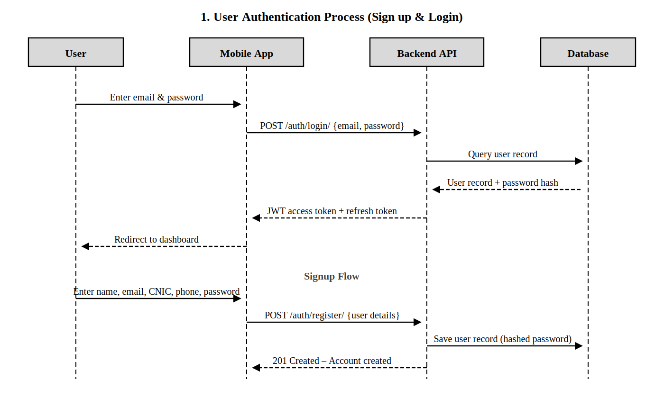
Figure 3.5 : Sequence Diagram – User Authentication (Sign up & Login)

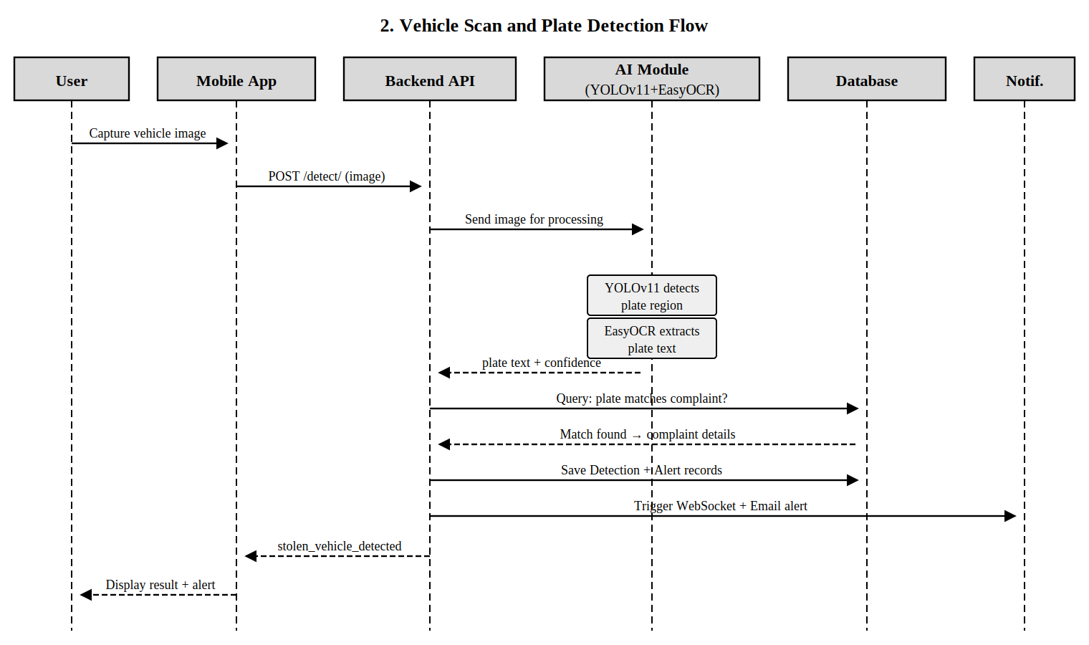
Figure 3.6 : Sequence Diagram – Vehicle Scan and Plate Detection Flow

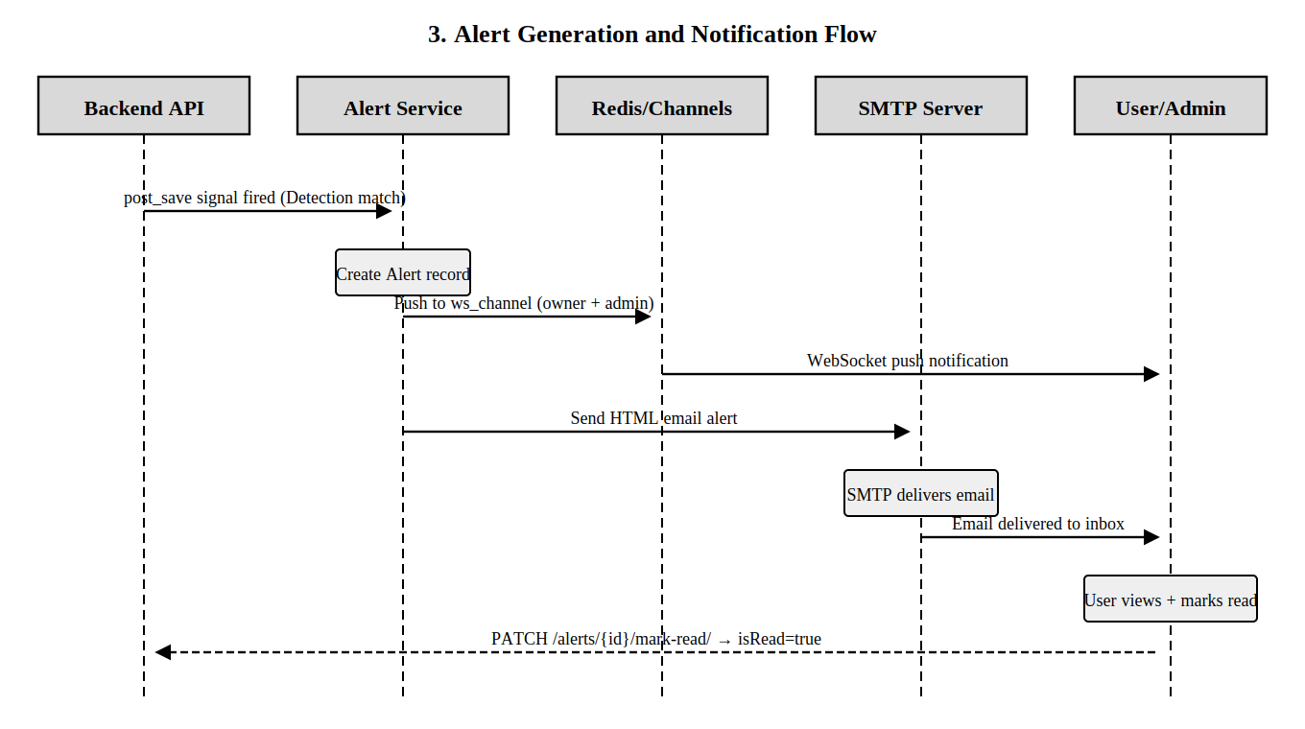
Figure 3.7 : Sequence Diagram – Alert Generation and Notification

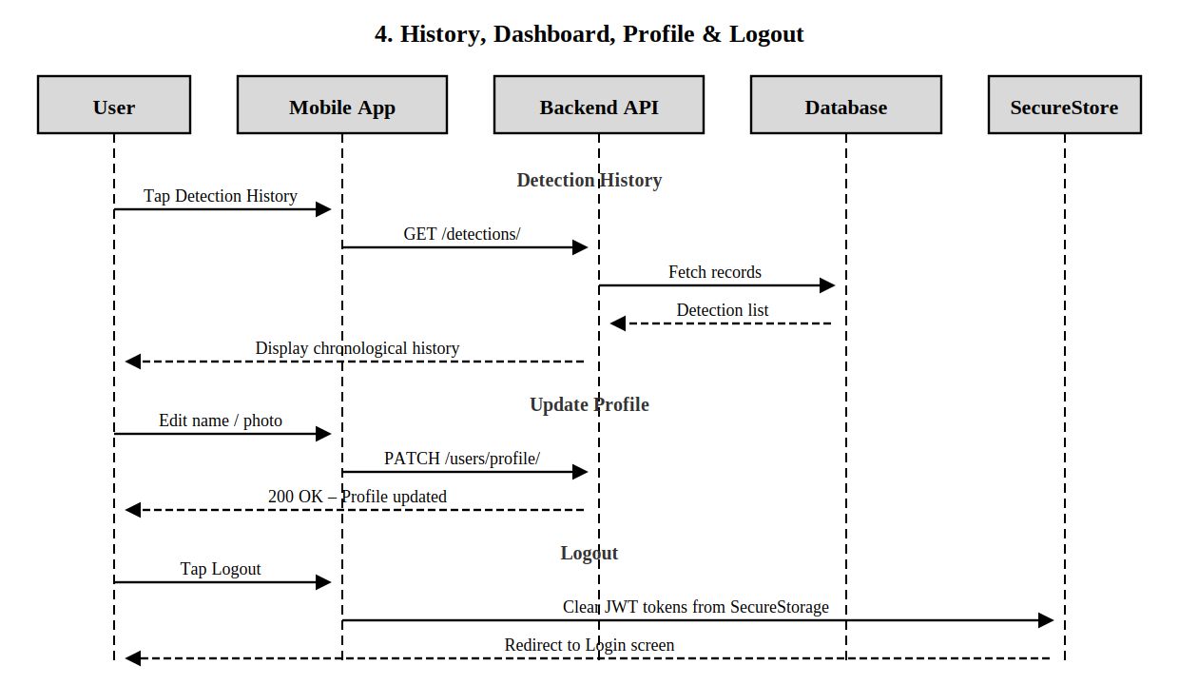
Figure 3.8 : Sequence Diagram – History, Dashboard, Profile & Logout

GUI – Graphical User Interfaces
The Graphical User Interface (GUI) of the Intelligent Vehicle Monitoring System (IVMS) is designed to be simple, responsive, and user-friendly for both mobile application users and web administrators. It provides smooth navigation, readable layouts, clear buttons, and easy access to all important features. Since the project contains both mobile and web platforms, the GUI section is divided into two parts.

3.8.1 Mobile Application GUI Screens

3.8.1.1 Login Screen
This screen allows users to securely log in using registered email and password. It provides secure access to the mobile application.
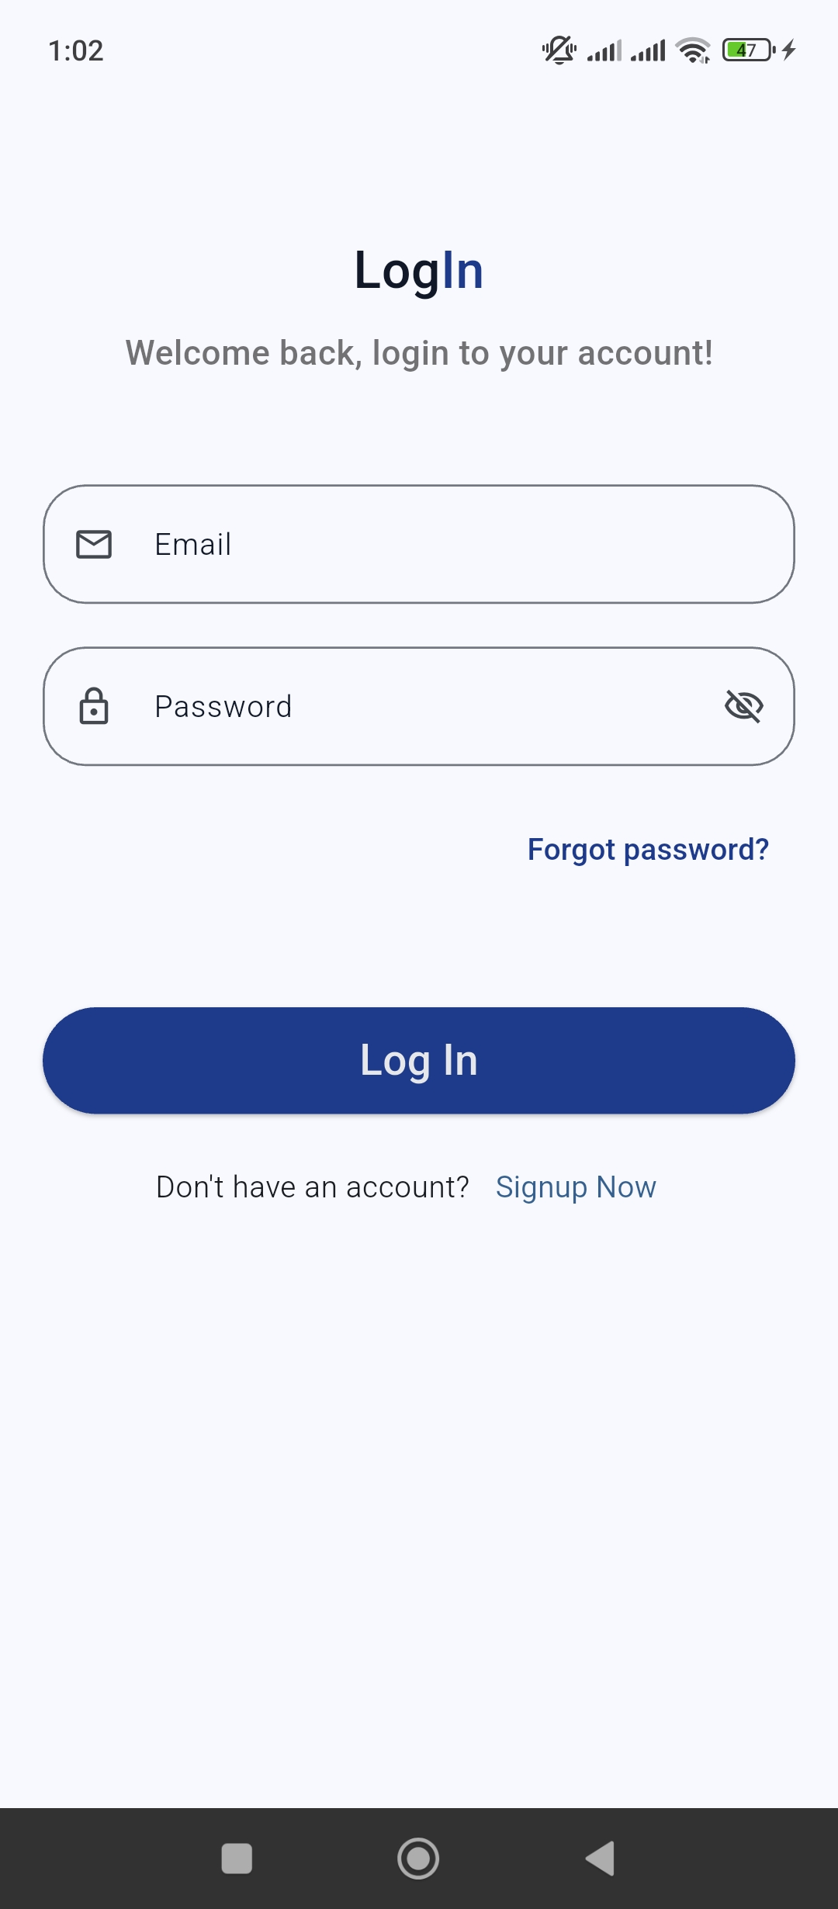
Figure 3.9 : Mobile Login Screen

3.8.1.2 Signup Screen
This screen allows new users to create an account by entering required details such as name, email, CNIC, phone number, and password.
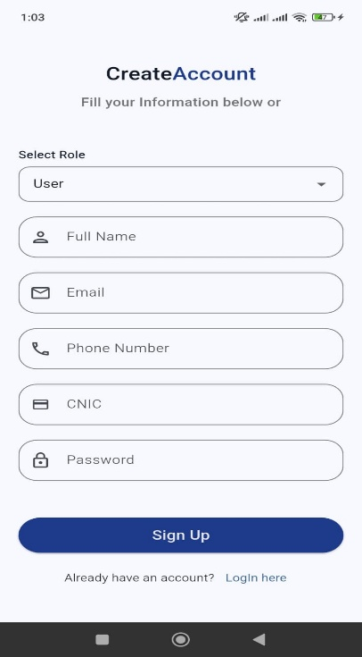

Figure 3.10 : Mobile Signup Screen

3.8.1.3 Dashboard Screen
This screen is the main page of the mobile application and provides quick access to all major features.
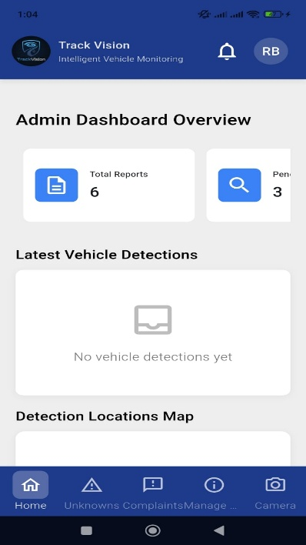
Figure 3.11 : Mobile Dashboard Screen

3.8.1.4 Scan Vehicle Screen
This section allows users to capture a vehicle image using camera or upload image from gallery for plate detection.
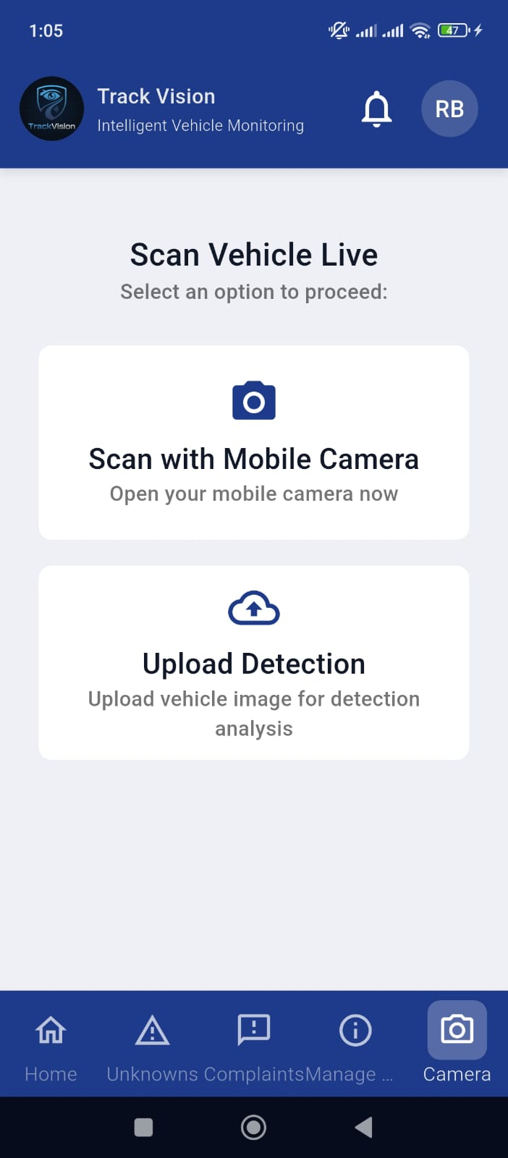
Figure 3.12 : Mobile Scan Vehicle Screen

3.8.1.5 Vehicle Detection Screen
This section displays detected number plate, scan result, and stolen vehicle status after processing.
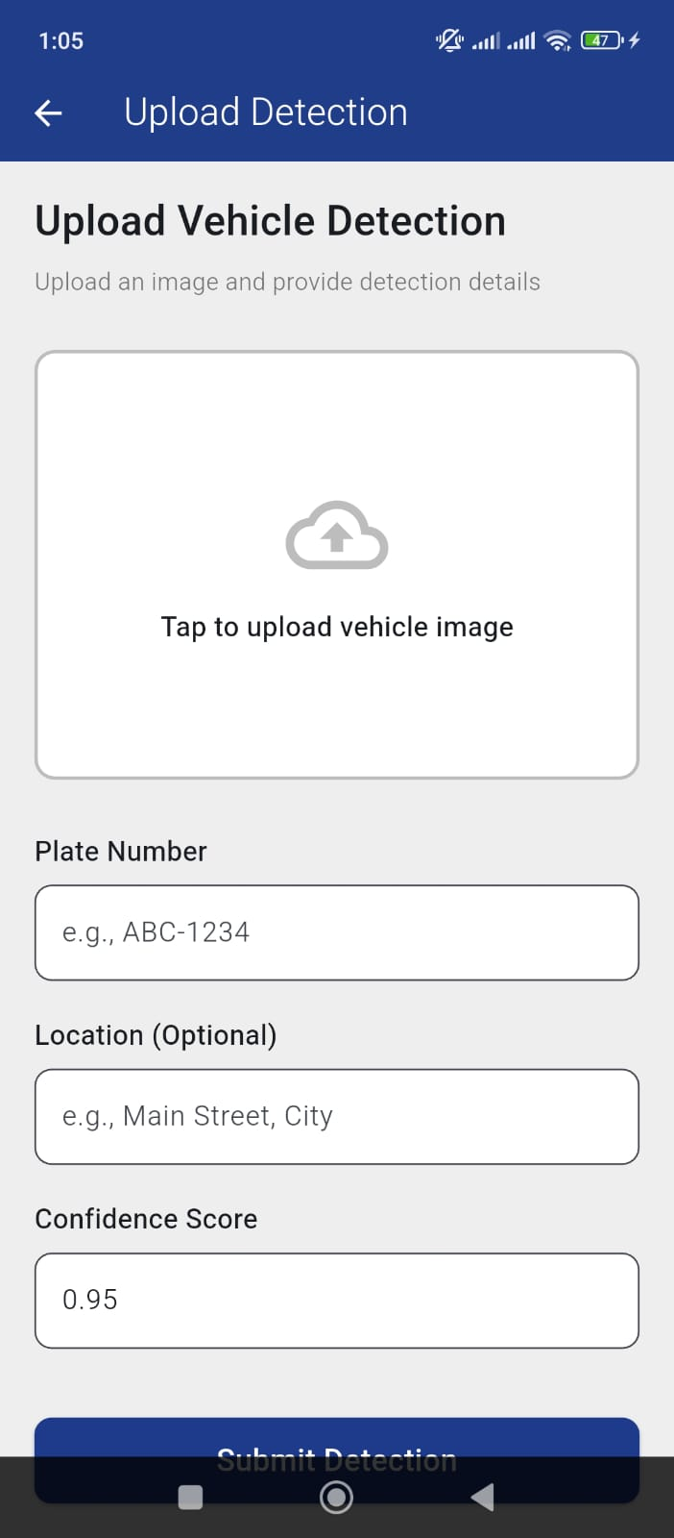
Figure 3.13 : Mobile Vehicle Detection Screen

3.8.1.6 Search Complaint Screen
This section allows users to search complaint records by complaint ID or vehicle number.
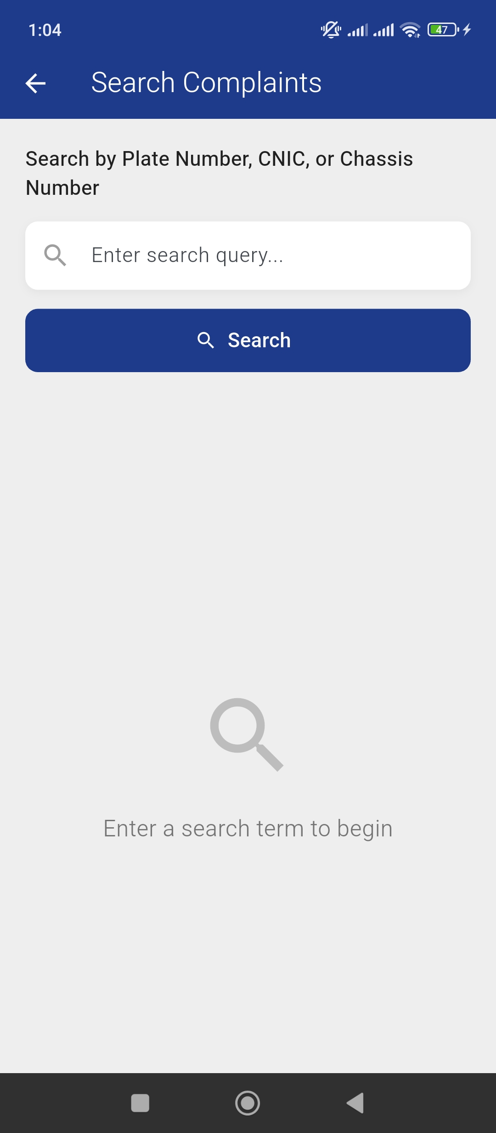

Figure 3.14 : Mobile Search Complaint Screen

3.8.1.7 Submit Complaint Screen
This section allows users to submit stolen vehicle complaints by entering owner and vehicle information.
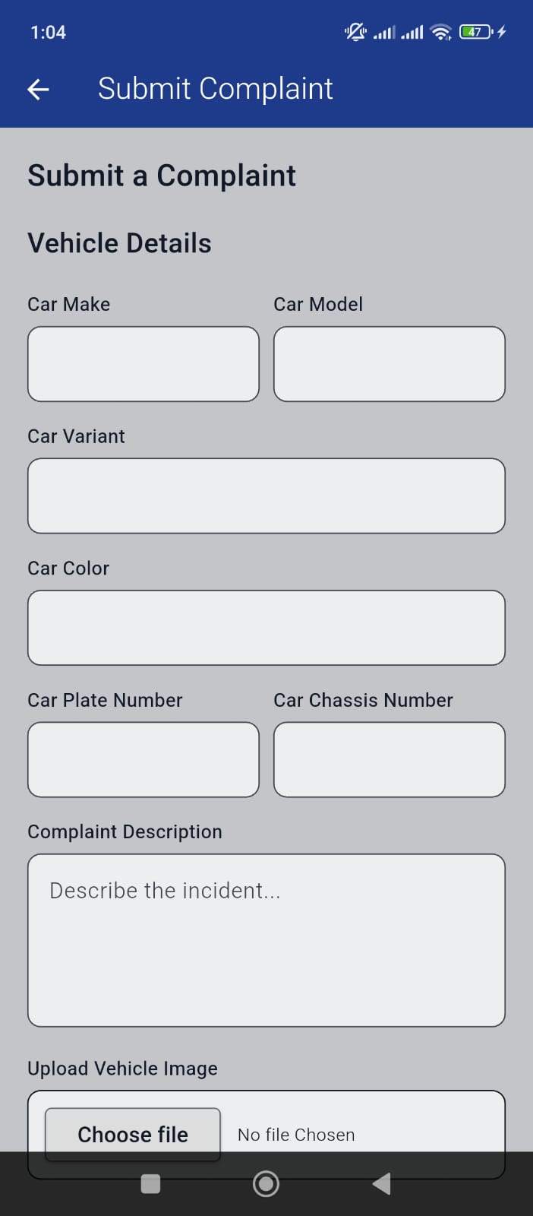
Figure 3.15 : Mobile Submit Complaint Screen

3.8.1.8 Vehicle Complaint Screen
This section displays complaint details related to stolen or suspicious vehicles.
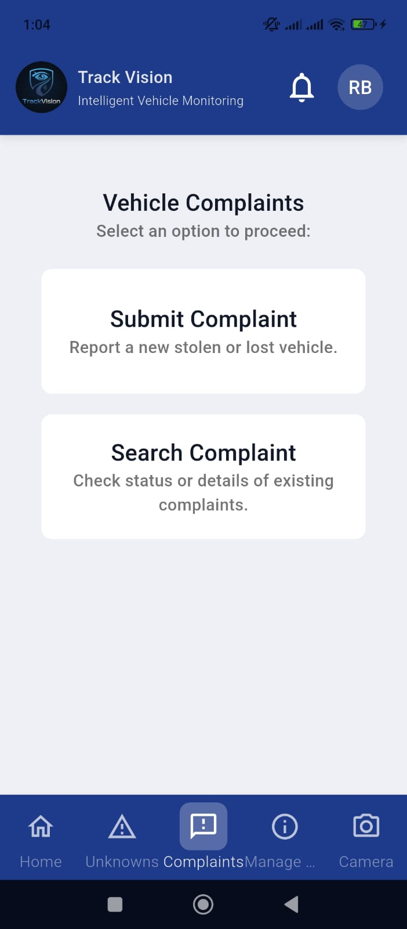
Figure 3.16 : Mobile Vehicle Complaint Screen

3.8.1.9 Alert Screen
This section shows alerts generated when a stolen vehicle is detected by the system.
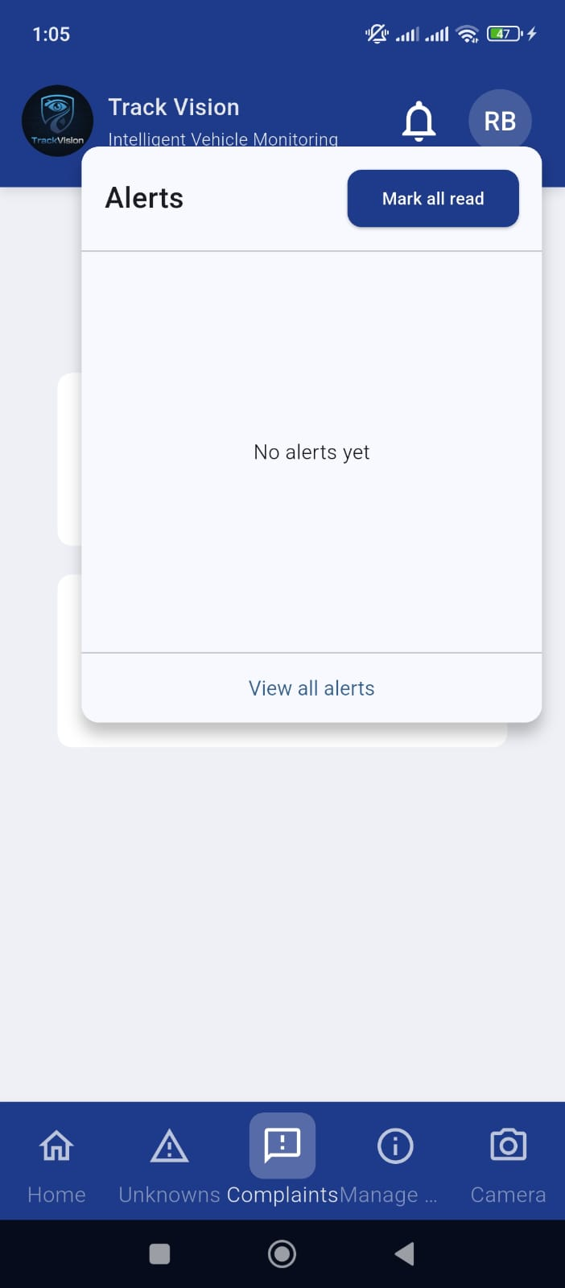
Figure 3.17 : Mobile Alert Screen

3.8.1.10 Complaint Management Screen
This section allows authorized users to manage submitted complaints and track their status.

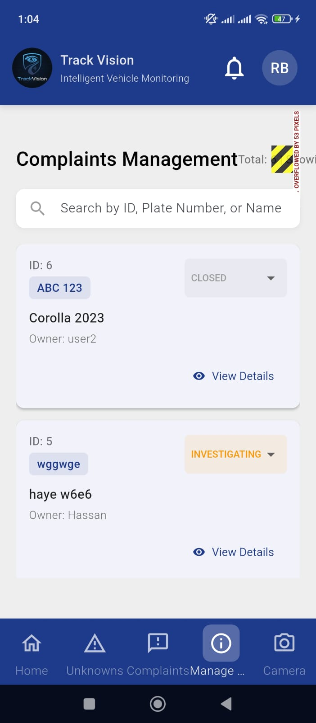
Figure 3.18 : Mobile Complaint Management Screen

3.8.1.11 User Profile Screen
This section allows users to view and update personal profile information.
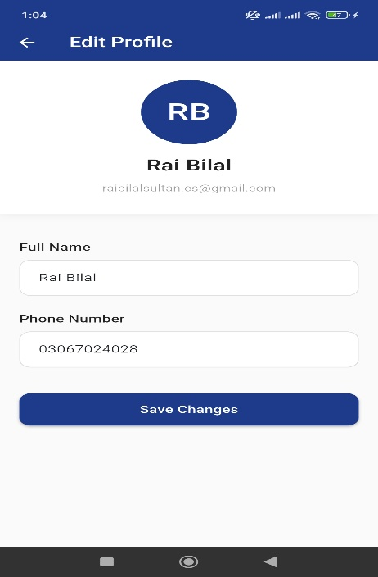

Figure 3.19 : Mobile User Profile Screen

3.8.1.12 Logout Screen
This section allows users to securely log out from the mobile application.
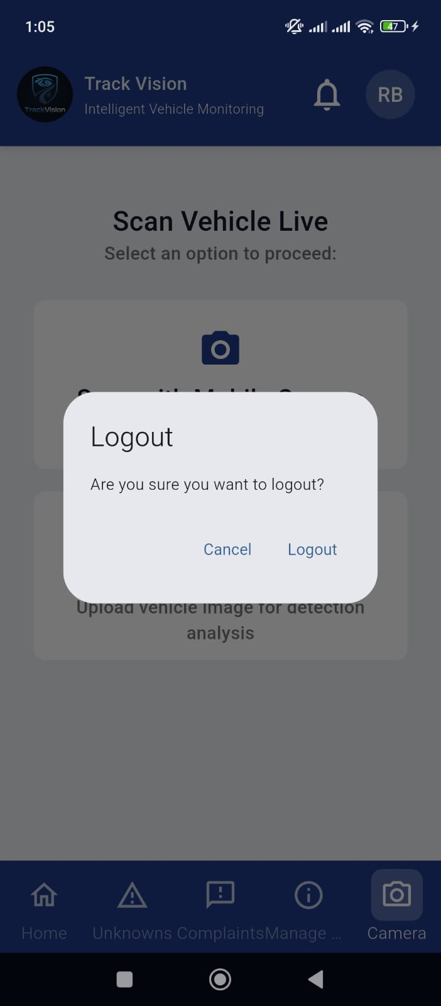
Figure 3.20 : Mobile Logout Screen

3.8.2 Web Application GUI Screens

3.8.2.1 Login Screen
This screen allows administrator or users to securely log in to the web portal.
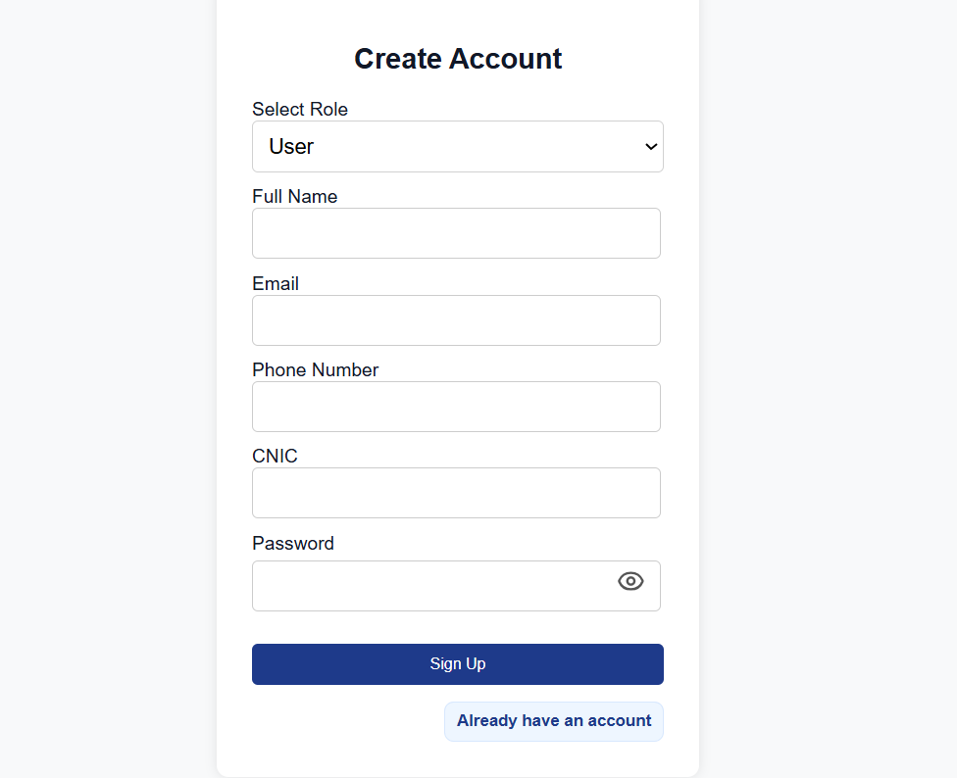
Figure 3.21 : Web Login Screen

3.8.2.2 Signup Screen
This screen allows new users to create account on the web application.

Figure 3.22 : Web Signup Screen

3.8.2.3 Dashboard Screen
This section provides overview of system statistics, detections, complaints, and alerts.
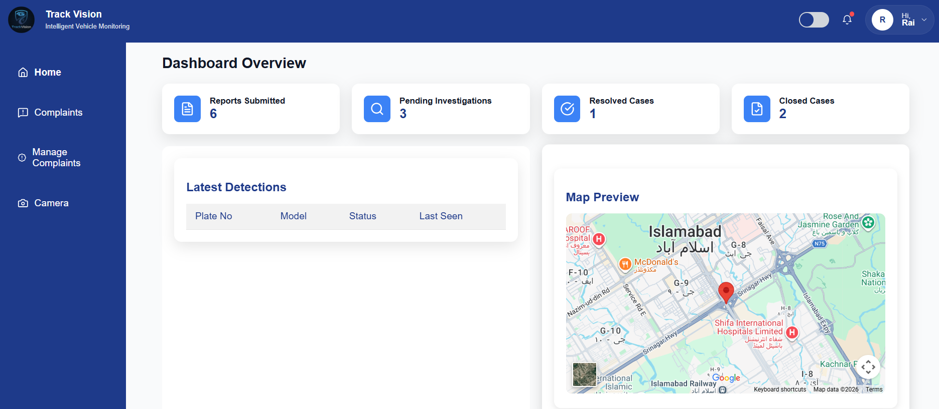
Figure 3.23 : Web Dashboard Screen

3.8.2.4 Vehicle Complaint Screen
This section displays stolen vehicle complaint records and related details.

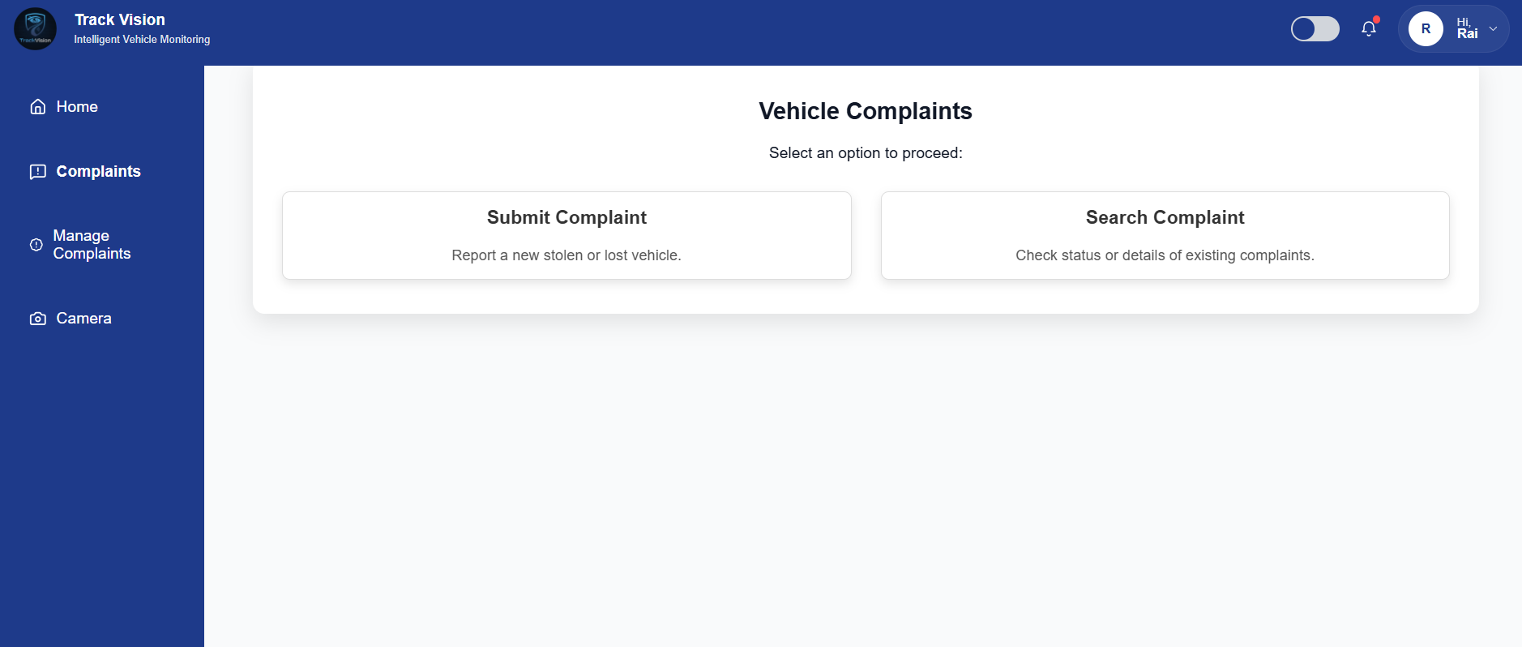
Figure 3.24 : Web Vehicle Complaint Screen

3.8.2.5 Submit Complaint Screen
This section allows users to register complaints through web portal.

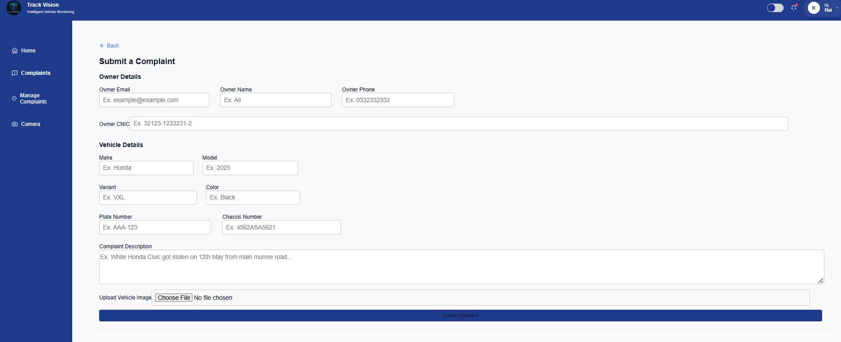
Figure 3.25 : Web Submit Complaint Screen

3.8.2.6 Search Screen
This section allows users to search complaint records or vehicle details.
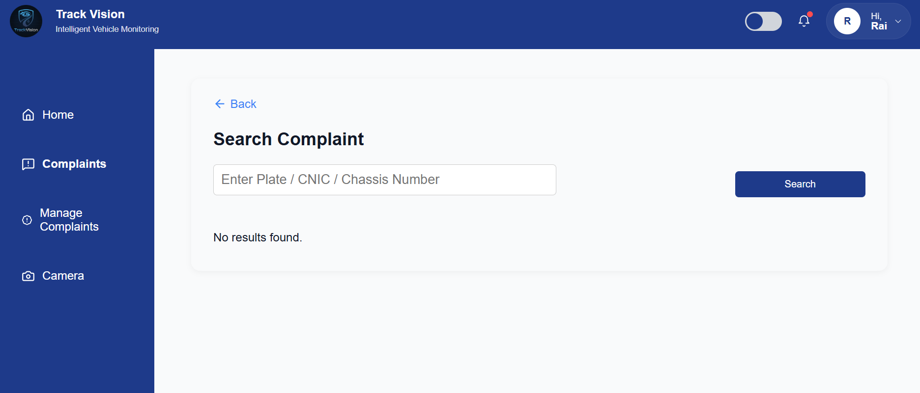
Figure 3.26 : Web Search Screen

3.8.2.7 Complaint Management Screen
This section allows admin to manage all complaints and update their status.
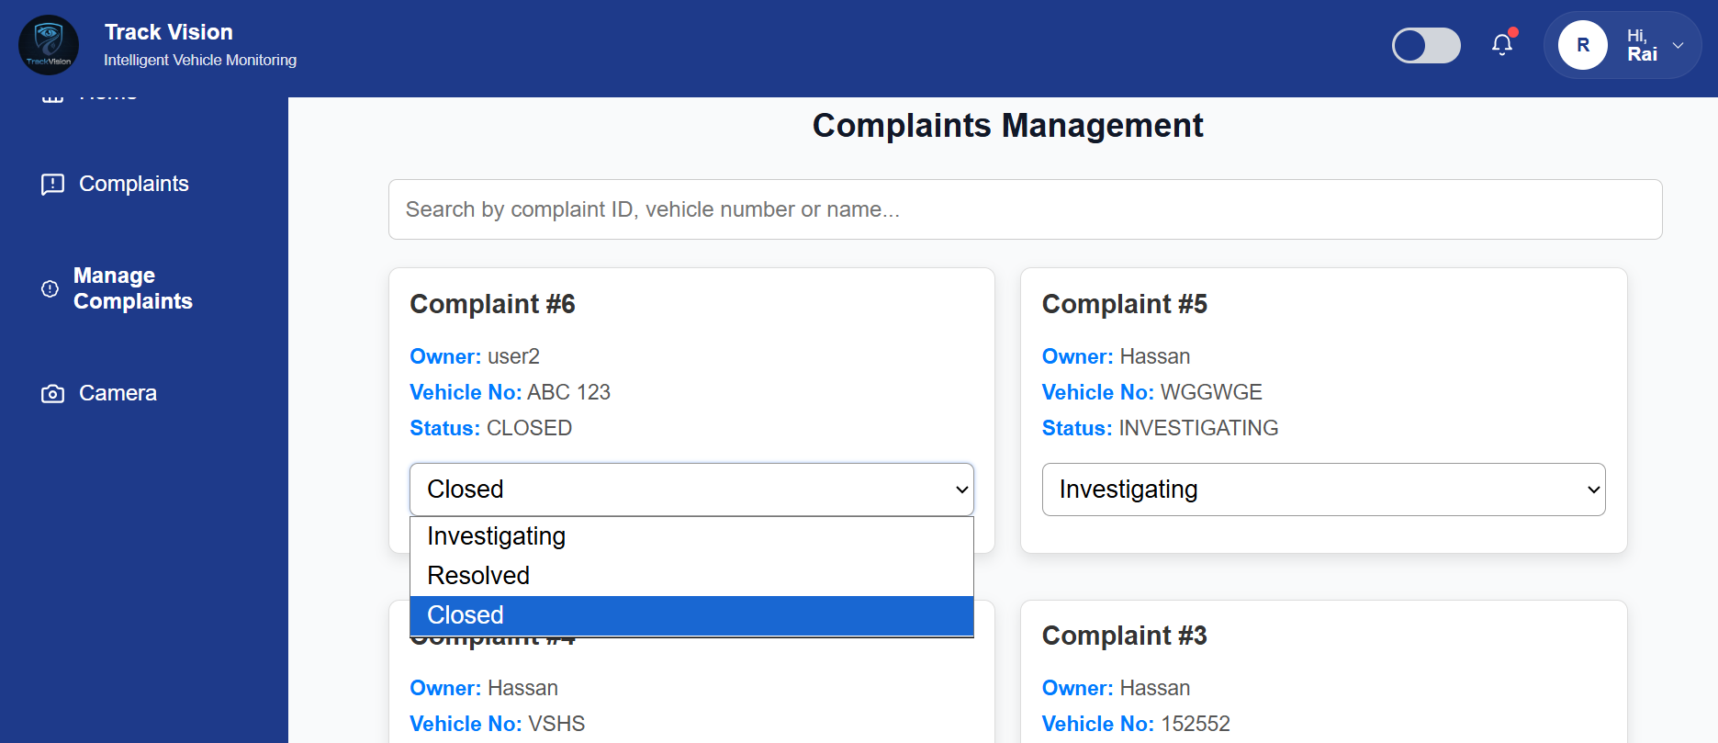
Figure 3.27 : Web Complaint Management Screen

3.8.2.8 Scan Vehicle Screen
This section allows vehicle scanning through uploaded images or connected devices.
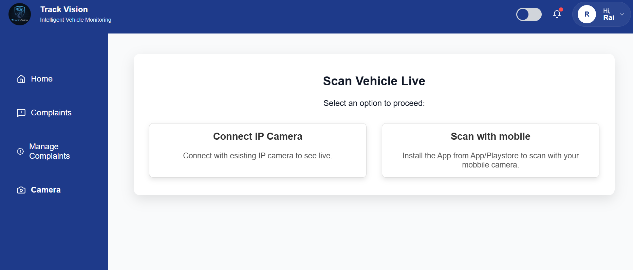
Figure 3.28 : Web Scan Vehicle Screen

3.8.2.9 Connect with IP Camera Screen
This section allows system connection with live IP camera feed for real-time monitoring and scannin
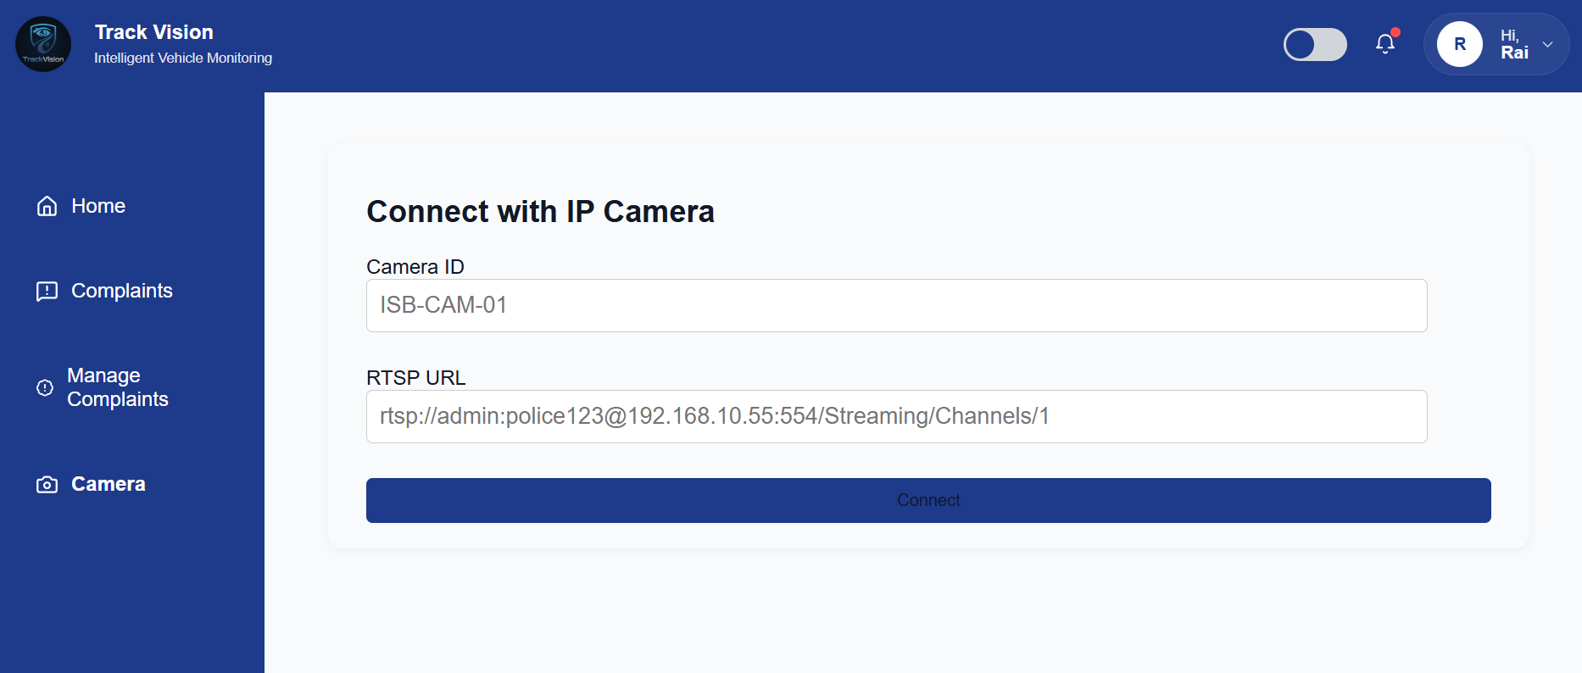
g.
Figure 3.29 : Web Connect with IP Camera Screen

3.8.2.10 Profile Screen
This section allows users/admin to manage profile information.

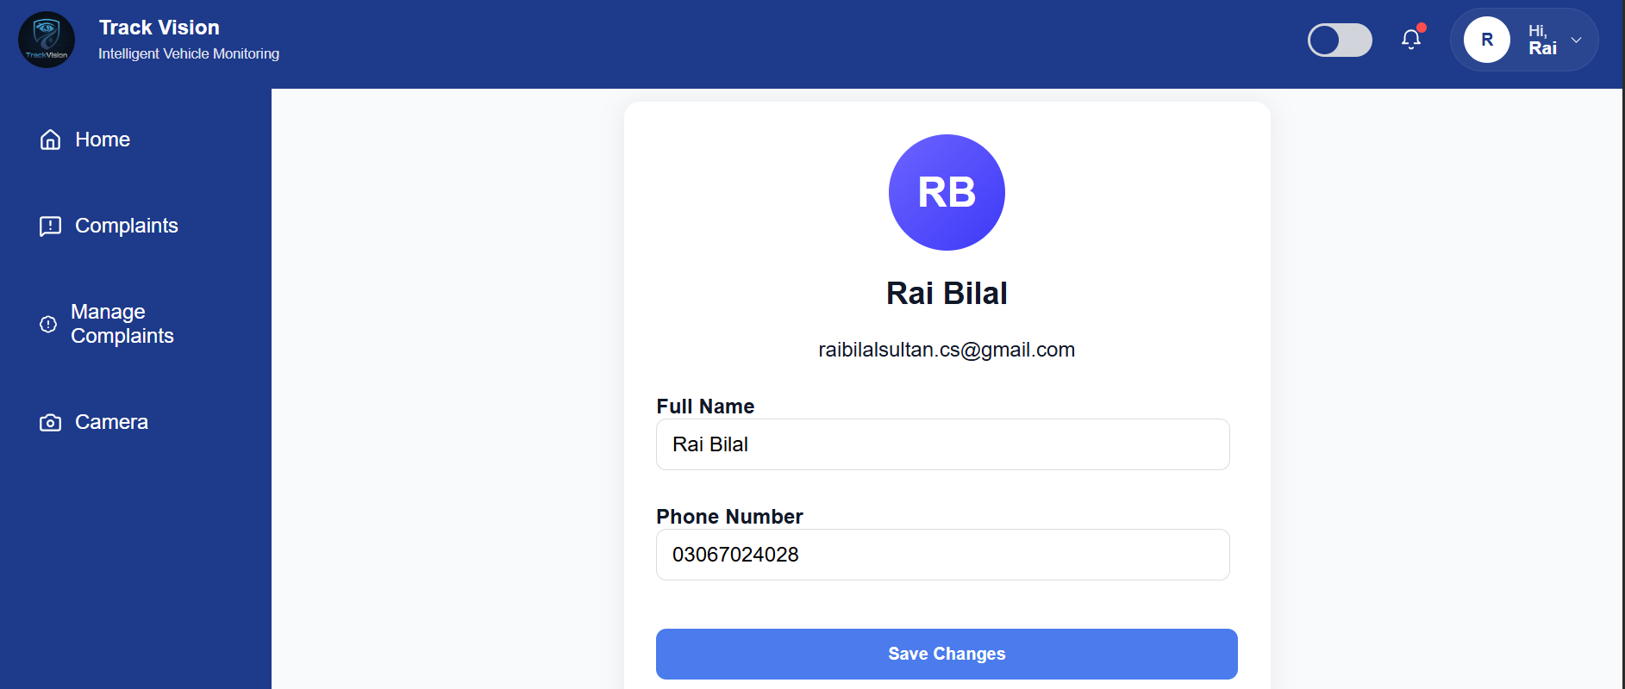
Figure 3.30 : Web Profile Screen

3.8.2.11 Dark Mode Screen
This section provides dark theme interface for better user experience.

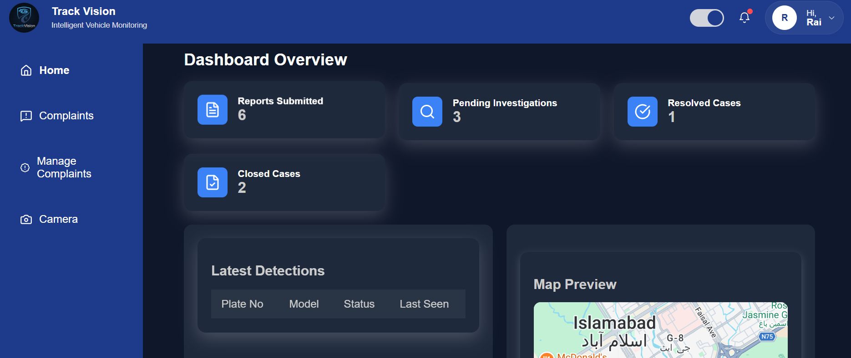
Figure 3.31 : Web Dark Mode Screen

3.8.2.12 Alerts Screen
This section displays all alerts generated through detections and complaint matches.

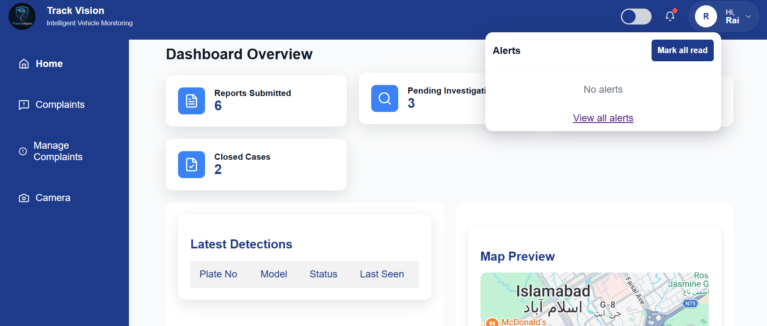
Figure 3.32 : Web Alerts Screen

3.8.3 GUI Summary
The IVMS GUI provides an effective and user-friendly environment for both mobile and web users. The mobile application focuses on field operations such as scanning vehicles, complaints, and alerts, while the web application provides monitoring, management, camera connectivity, and administrative features.

Implementation and Test Cases

Introduction
This chapter presents the complete implementation of the proposed Intelligent Vehicle Monitoring System (IVMS) along with the testing methodology used to validate its functionality and performance. The system is designed to perform real-time vehicle detection, license plate recognition, and alert generation using deep learning and computer vision techniques.
The implementation integrates multiple technologies, including artificial intelligence, web development, and mobile application frameworks, to build a scalable and efficient monitoring solution. The core of the system is based on a YOLO (You Only Look Once) object detection model combined with Optical Character Recognition (OCR) for extracting license plate information.
This chapter also describes the system architecture, data preprocessing techniques, model training strategy, and module-level implementation. Furthermore, structured test cases and evaluation metrics are presented to ensure system reliability, correctness, and robustness.

4.1 Implementation
The Intelligent Vehicle Monitoring System (IVMS) is implemented using a combination of artificial intelligence, web technologies, and mobile application frameworks. The system follows a modular architecture in which each component performs a specific function, ensuring scalability, efficiency, and real-time performance.
The backend of the system is developed using Python with the Django framework, which handles API requests, database operations, authentication, and alert management. The frontend dashboard is developed using React.js and Tailwind CSS to provide an interactive and responsive user interface. Additionally, a mobile application is built using Flutter to enable real-time alert notifications and user interaction.
For intelligent processing, the system integrates a deep learning-based object detection model along with Optical Character Recognition (OCR) techniques to detect vehicles and extract license plate information.

Data Acquisition and Preprocessing
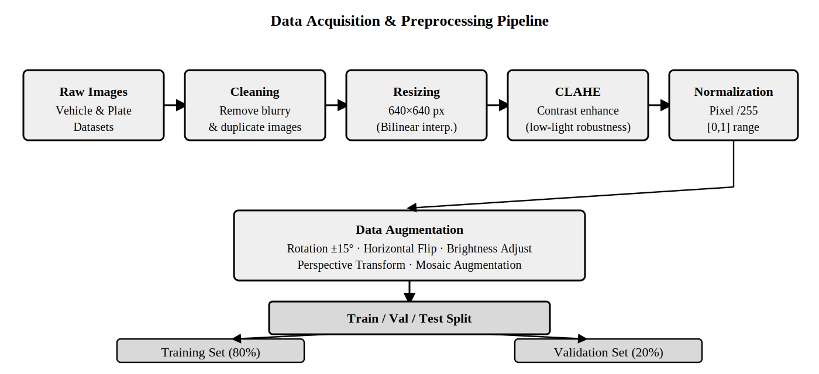
Figure 4.1 : Data Acquisition and Preprocessing Pipeline

The system begins with collecting vehicle images from various sources, including CCTV cameras, IP cameras, and datasets. Since raw data may contain noise, inconsistencies, and irrelevant samples, preprocessing is essential.
The preprocessing pipeline includes:
- Removal of blurred and duplicate images
- Resizing images to 640×640 resolution
- Contrast enhancement using CLAHE
- Normalization of pixel values to [0,1]
To improve generalization, the following augmentation techniques are applied:
- Rotation (±15 degrees)
- Horizontal flipping
- Brightness adjustment
- Perspective transformation
- Mosaic augmentation
The dataset is split into:
- Training set (80%)
- Validation set (20%)

4.1.2 YOLO-Based Detection and OCR Pipeline
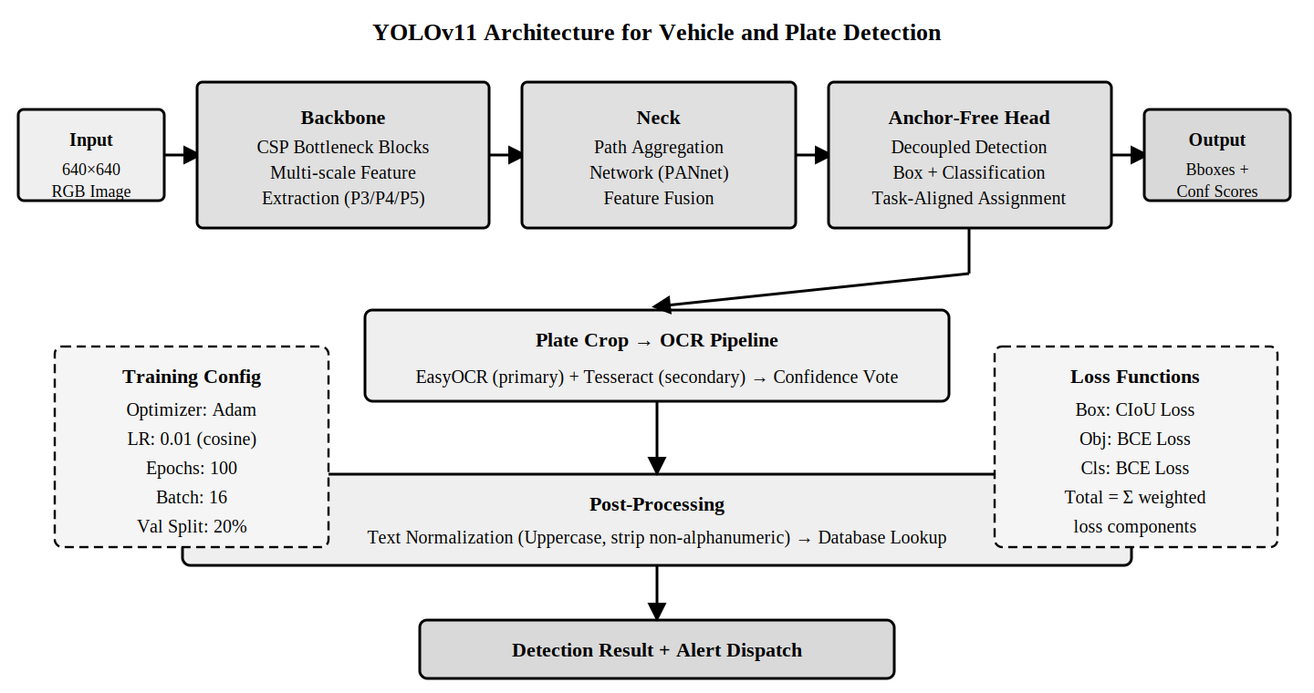
Figure 4.2 : YOLO Architecture Diagram

The core detection mechanism of the IVMS system is based on the YOLO (You Only Look Once) deep learning model, which enables real-time object detection with high accuracy.
As shown in Figure 4.2, the input image is processed through a backbone network that extracts important visual features using CSP (Cross Stage Partial) blocks. These features are then passed to the neck component, which uses a Path Aggregation Network (PANet) to combine multi-scale features.
The detection head is anchor-free and performs bounding box regression and classification simultaneously. It outputs the locations of detected vehicles and license plates along with confidence scores.
Once a license plate is detected, the corresponding region is cropped and passed to the OCR pipeline. EasyOCR is used as the primary text recognition engine, while Tesseract is used as a secondary engine to improve accuracy through a confidence-based voting mechanism.
The extracted text is then normalized by converting it to uppercase and removing non-alphanumeric characters before being matched with the system database.

4.1.3 Vehicle Detection Module
The vehicle detection module is responsible for identifying vehicles from images or live video streams in real time.
- Input is captured from CCTV cameras, IP cameras, or uploaded images
- Video streams are processed by extracting frames at regular intervals
- The YOLO model is applied to detect vehicles within each frame
- Bounding boxes are drawn around detected vehicles
- Detected regions are forwarded for further processing
This module ensures accurate and efficient vehicle localization under different environmental conditions.

4.1.4 Number Plate Recognition Module
The number plate recognition module extracts and processes license plate text from detected vehicles.
- The license plate region is cropped from the detected vehicle
- Image preprocessing techniques such as grayscale conversion and noise reduction are applied
- OCR is performed using EasyOCR and Tesseract
- Extracted text is validated and normalized
- Final plate number is prepared for database comparison
The use of multiple OCR engines increases reliability and improves recognition accuracy.

4.1.5 Backend Implementation
The backend serves as the core processing unit of the IVMS system, managing communication between different modules and handling system logic.
- Developed using Django framework (Python)
- Uses MySQL database for storing vehicle records, plate numbers, alerts, and user data
- Receives detection results from AI modules
- Matches extracted plate numbers with the stolen vehicle database
- Provides RESTful APIs for frontend and mobile application integration
- Implements user authentication and role-based access control
- Maintains logs of detections, alerts, and timestamps
This ensures secure, efficient, and scalable system operation.

4.1.6 Alert Generation Module
The alert generation module is responsible for notifying users when a suspicious or stolen vehicle is detected.
- Extracted plate number is compared with database records
- If a match is found, an alert is triggered
- Alerts are displayed on the web dashboard
- Notifications are sent to the mobile application
- Email alerts are generated for registered users
This module enables real-time monitoring and quick response to incidents.

4.1.7 System Workflow Architecture
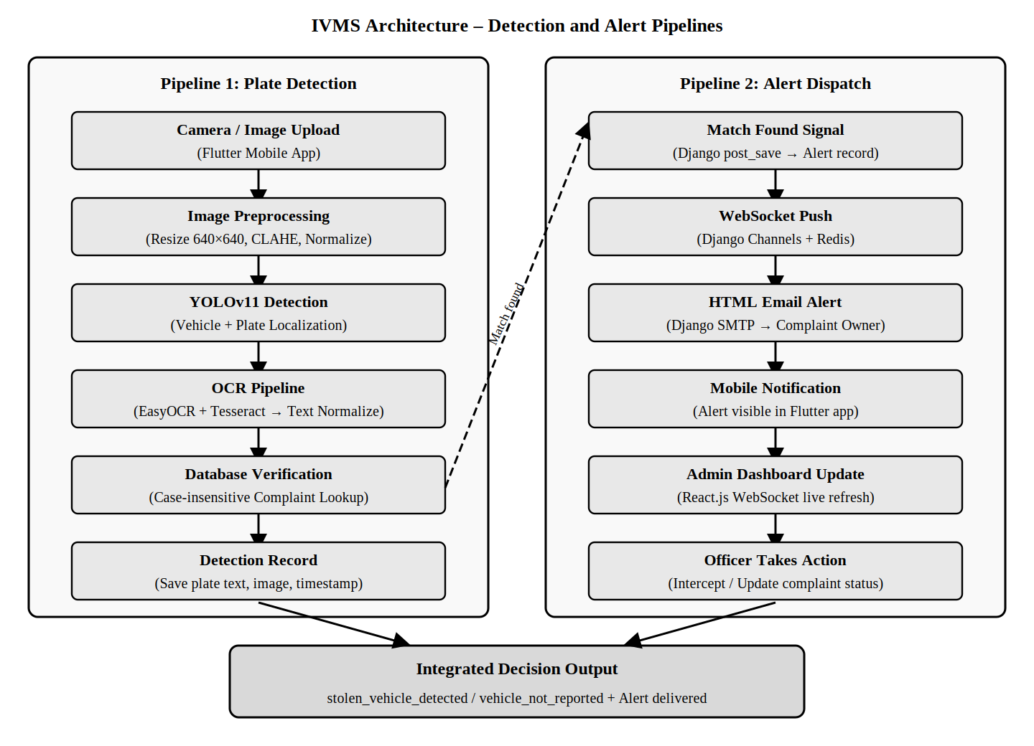
Figure 4.3 : IVMS Architecture (Detection + Alert Pipelines)

Figure 4.3 illustrates the overall workflow of the IVMS system. The process starts with capturing images through cameras or mobile devices. The images are preprocessed and passed to the YOLO model for detection.
The detected license plate region is processed by the OCR module to extract text, which is then verified against the database. If a match is found, alerts are generated and dispatched through multiple channels, including WebSocket, email, and mobile notifications.
The system also updates the admin dashboard in real time, allowing authorities to monitor activities and take appropriate actions.

4.2 Test Case Design and Description
The following test cases validate the core functional requirements of the IVMS system.

4.2.1 Test Case TC-01: User Login
Test Case ID | TC-01
Use Case Reference | UC 3.4.4.1 - Login
Objective | Verify a registered user can log in with valid credentials and is redirected to dashboard.
Pre-Requisite | User account must exist in the system.
Step 1 | Open the login screen in the Flutter mobile application.
Step 2 | Enter a valid registered email and correct password.
Step 3 | Tap the Login button.
Expected Result | System authenticates user, returns JWT token, navigates to user dashboard.
Actual Result | User redirected to dashboard. Token stored securely in device storage.
Status | Passed

4.2.2 Test Case TC-02: AI Plate Detection
Test Case ID | TC-02
Use Case Reference | UC 3.4.4.4 - Scan Vehicle
Objective | Verify AI module correctly detects and reads vehicle license plate from an uploaded image.
Pre-Requisite | Clear vehicle image with visible plate. AI module running on backend.
Step 1 | Open Camera screen in the Flutter app.
Step 2 | Capture or upload a clear vehicle image.
Step 3 | Submit image to POST /detect/ endpoint.
Expected Result | AI detects plate, reads text, normalizes it, matches against complaint database.
Actual Result | Plate text correctly identified. Alert generated and sent via WebSocket and email.
Status | Passed

4.2.3 Test Case TC-03: Submit Complaint
Test Case ID | TC-03
Use Case Reference | UC 3.4.4.3 - Submit Complaint
Objective | Verify logged-in user can submit a stolen vehicle complaint with all required fields.
Pre-Requisite | User must be logged in. Required complaint fields prepared.
Step 1 | Navigate to Submit Complaint screen.
Step 2 | Fill all required owner and vehicle information.
Step 3 | Optionally upload vehicle picture and write description.
Step 4 | Tap the Submit button.
Expected Result | Complaint saved with status Investigating. Confirmation shown with complaint ID.
Actual Result | Complaint created in database and visible in admin panel.
Status | Passed

4.3 Test Metrics
Metric | Description / Value
Number of Test Cases | 3 test cases for FYP-1 (TC-01 Login, TC-02 Plate Detection, TC-03 Submit Complaint).
Number of Test Cases Passed | 3 — All test cases passed successfully.
Number of Test Cases Failed | 0
Test Case Defect Density | (0 failed x 100) / 3 executed = 0%
Test Case Effectiveness | No defects detected during FYP-1 prototype testing.
Traceability Matrix | TC-01 → FR-1.2 (Login); TC-02 → FR-3.1 to FR-3.8 (AI); TC-03 → FR-1.6 (Submit Complaint).

4.4 Model Evaluation Metrics
The performance of the object detection model is evaluated using standard evaluation metrics. These metrics help in measuring detection accuracy, localization quality, and overall model effectiveness.

4.4.1 Precision
Precision measures the proportion of correctly predicted positive detections out of all predicted detections.
Precision= TP / (TP + FP)
Where:
TP = True Positives
FP = False Positives

4.4.2 Recall
Recall measures the proportion of correctly detected objects out of all actual objects.
Recall= TP / (TP + FN)
Where:
FN = False Negatives

4.4.3 Intersection over Union (IoU)
IoU measures the overlap between the predicted bounding box and the ground truth box.
IoU= Area of Overlap / Area of Union

4.4.4 Mean Average Precision (mAP)
mAP represents the average of the Average Precision (AP) values across all classes.
mAP= (1 / N) * sum from i = 1 to N of AP_i
Where:
N = Total number of classes
AP = Average Precision for each class

4.5 Conclusion
This chapter presented the implementation details of the IVMS system, including AI models, backend, and user interfaces. The system was successfully tested using multiple test cases, demonstrating its capability to perform real-time vehicle detection, recognition, and alert generation efficiently.

Experimental Results and Analysis

Introduction
This chapter presents the experimental evaluation and performance analysis of the proposed Intelligent Vehicle Monitoring System (IVMS). The main objective of this evaluation is to measure how effectively the system performs in real-world conditions, particularly in terms of vehicle detection, license plate recognition, and real-time alert generation.
The system is developed using deep learning-based object detection and optical character recognition techniques. Therefore, its performance is assessed using standard evaluation metrics such as precision, recall, mean Average Precision (mAP@50), and mAP@50-95. These metrics collectively provide a clear understanding of detection accuracy, localization performance, and overall system reliability.
The experiments are conducted under different environmental and operational conditions to ensure robustness and real-world applicability of the system.

5.1 Experimental Setup
The proposed IVMS system is evaluated using both real-time and offline data sources to ensure comprehensive testing.

Data Sources
The system is tested using:
- Real-time camera feeds from surveillance setups
- Pre-collected image datasets containing vehicles under different conditions
These datasets include variations such as different vehicle types, angles, distances, and lighting conditions.

Tools and Technologies Used
The implementation and testing of the system involve the following tools and frameworks:
- Python & Django → Backend development and API handling
- OpenCV → Image processing and video frame handling
- YOLO (You Only Look Once) → Real-time object detection model
- EasyOCR & Tesseract OCR → License plate text recognition

Testing Conditions
To evaluate robustness, the system is tested under multiple challenging scenarios:
- Bright daylight conditions
- Low-light and night-time environments
- Moving vehicles with motion blur
- Partially occluded or damaged number plates
These conditions ensure that the system is not limited to controlled environments and can perform effectively in real-world surveillance situations.

5.3 Experimental Results
The performance of different trained models is evaluated using standard object detection metrics.

5.3.1 Model Performance Comparison
Experiment | Precision | Recall | mAP@50 | mAP@50-95
exp_60 | 99.80% | 99.30% | 99.50% | 85.40%
exp_70 | 99.37% | 98.70% | 99.42% | 87.26%
exp_80 | 98.65% | 98.11% | 99.04% | 87.27%

5.3.2 Visual Results
The following figures illustrate the performance of the selected model (exp_70) during training and evaluation.
This graph shows the training and validation performance of the model over epochs, including loss reduction and improvement in accuracy.

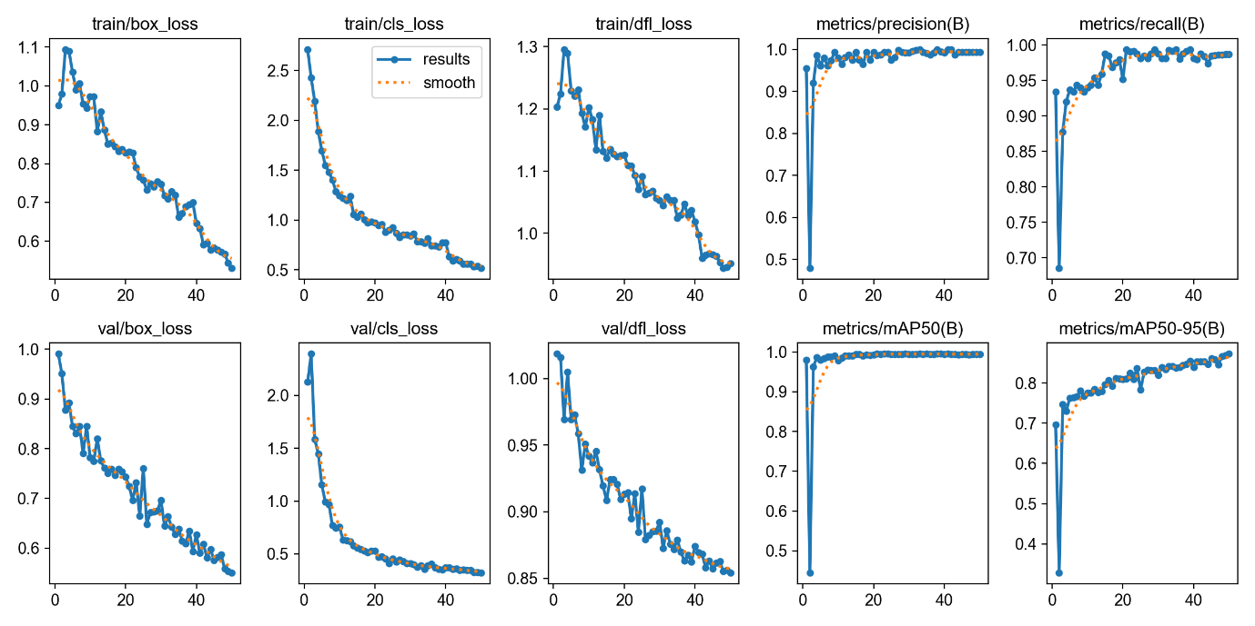
Figure 5.1: Training Results Graph
This curve demonstrates the trade-off between precision and recall, indicating the model’s ability to correctly detect vehicles while minimizing false detections.
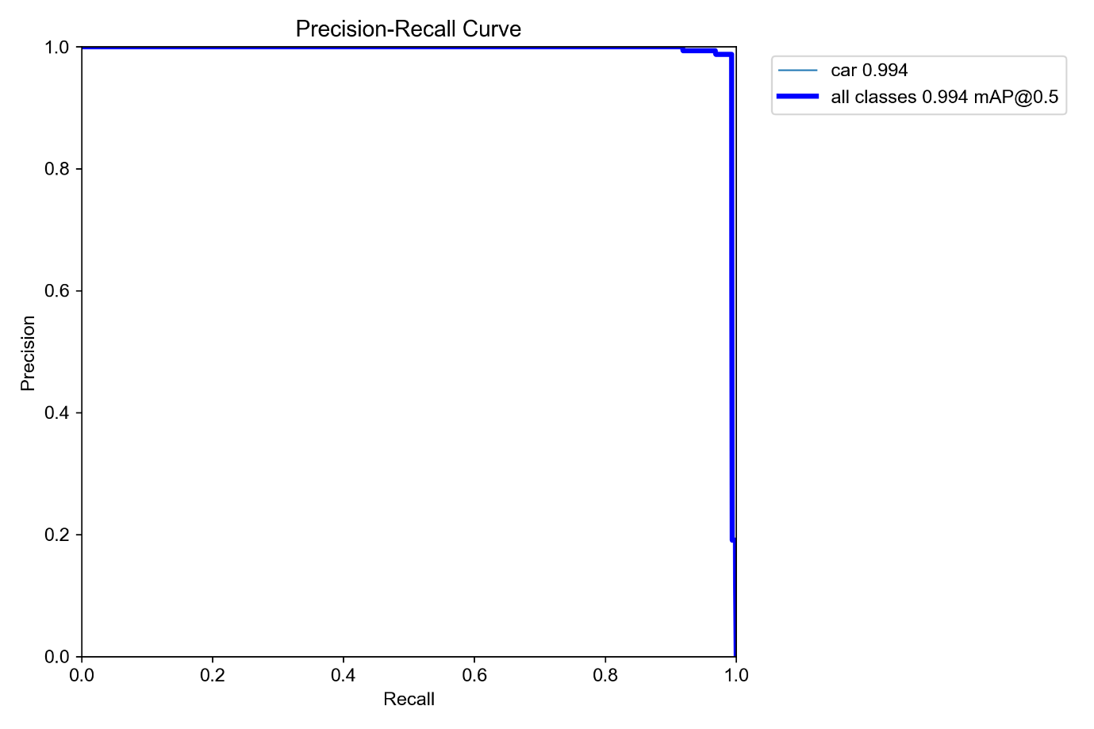
Figure 5.2: Precision–Recall Curve
The F1 score curve represents the balance between precision and recall across different confidence thresholds.
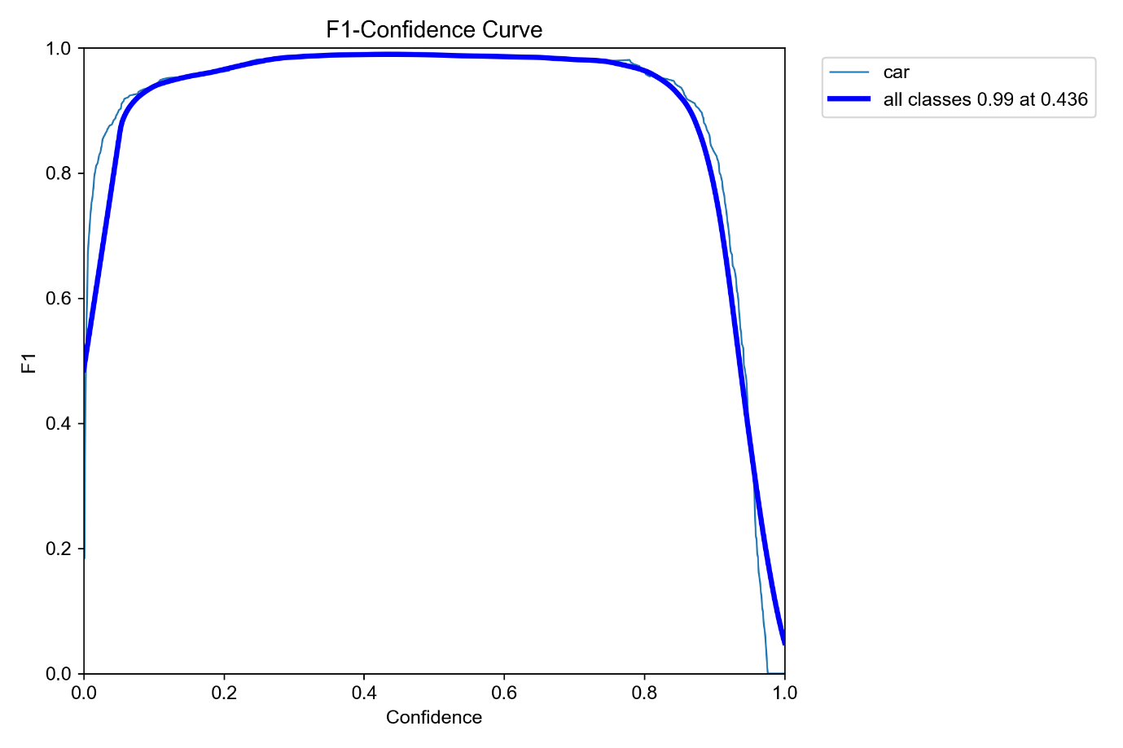

Figure 5.3: F1 Score Curve
The confusion matrix provides a detailed breakdown of correct and incorrect predictions, showing how well the model distinguishes between detected classes.
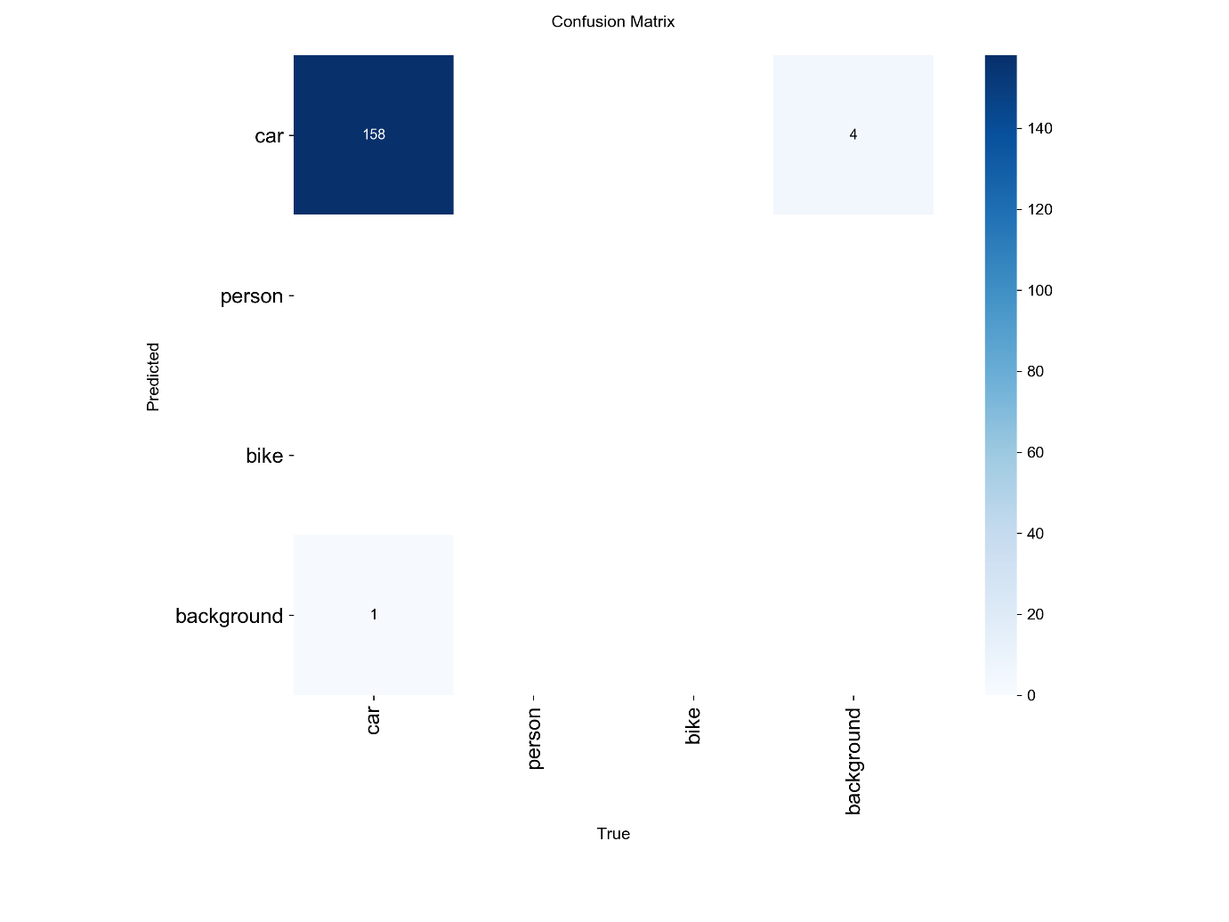
Figure 5.4: Confusion Matrix
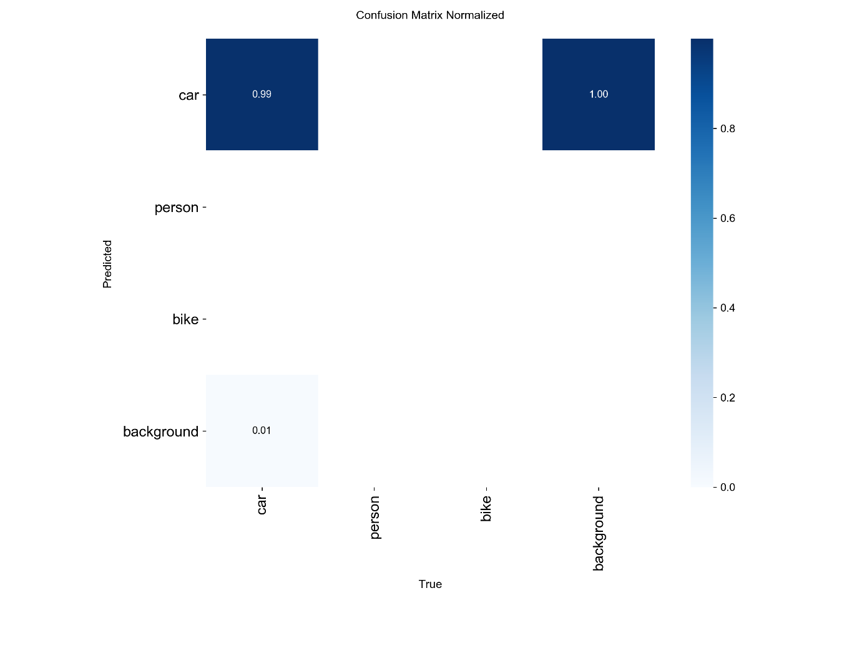

Figure 5.5: Normalized Confusion Matrix

5.4 Result Analysis
The experimental results indicate that all trained models perform strongly in vehicle detection and recognition tasks. However, differences are observed when evaluating their balance between precision, recall, and localization accuracy.

5.4.1 Overall Performance Evaluation
- exp_60 achieves the highest precision and recall values, indicating strong detection correctness. However, its lower mAP@50-95 suggests weaker performance under stricter IoU thresholds.
- exp_70 provides a balanced and stable performance across all metrics:
  - Precision: 99.37%
  - Recall: 98.70%
  - mAP@50: 99.42%
  - mAP@50-95: 87.26%
- exp_80 shows slightly lower precision and recall but a marginally higher mAP@50-95 of 87.27%.

5.4.2 Why exp_70 is Selected as the Best Model
Although exp_80 has a slightly higher mAP@50-95 (87.27%) compared to exp_70 (87.26%), the difference is only 0.01%, which is negligible and not practically significant.
exp_70 is selected as the best model for the following reasons:
1. Balanced Performance:
It maintains a strong balance between precision and recall, ensuring both low false positives and low false negatives.
2. Stable Behavior:
exp_70 shows more consistent and stable performance during training and evaluation.
3. Negligible mAP Difference:
The slight improvement in exp_80 is not meaningful enough to outweigh other performance factors.
4. Better Real-World Suitability:
exp_70 performs more reliably in real-time monitoring scenarios where consistency is more important than marginal metric improvements.
5. Optimal Trade-Off:
It provides the best overall balance between detection accuracy and localization quality.

5.5 Conclusion
This chapter presented the experimental evaluation of the proposed IVMS system. The results demonstrate that the system performs effectively under real-world conditions with high accuracy in vehicle detection and license plate recognition.
The integration of YOLO for object detection and OCR techniques for text recognition provides a robust and efficient solution for intelligent vehicle monitoring.
Among all tested models, exp_70 is selected as the most suitable model due to its balanced performance, stability, and reliability in real-time applications such as traffic monitoring and security surveillance

Conclusion and Future Directions

6.1 Conclusion
This project successfully designed and developed an AI-based Intelligent Vehicle Monitoring System (IVMS) for real-time vehicle detection, number plate recognition, and alert generation. The system integrates deep learning techniques, OCR technologies, and modern web and mobile platforms to provide an efficient and automated solution for vehicle monitoring.
The main objective of the project was to reduce manual effort in traffic monitoring and improve the accuracy and response time of detecting suspicious vehicles. These objectives have been successfully achieved through the implementation of real-time detection using YOLO, accurate license plate recognition using OCR, and automated verification through database integration.
The system demonstrated strong performance in experimental evaluation, achieving high accuracy and fast response time. The web dashboard and mobile application provide user-friendly interfaces for monitoring and alert management, making the system practical for real-world usage.
Overall, the project scope has been largely covered, and the system fulfills its intended purpose. However, some limitations remain, particularly in handling extreme environmental conditions and dependency on camera quality.

6.2 Challenges Faced
During the development of this project, several challenges were encountered:
- Difficulty in achieving high OCR accuracy for blurred or low-quality images
- Handling variations in lighting and weather conditions
- Integration of multiple technologies (AI, backend, frontend, mobile app)
- Real-time processing optimization
These challenges were addressed through model tuning, preprocessing techniques, and system optimization.

6.3 Limitations
- Performance depends on camera quality
- Reduced accuracy in low-light conditions
- Requires stable internet connection for real-time alerts
- Limited dataset for training AI models

6.4 Future Work
The system can be further enhanced in the following ways:
- Integration with official police and government databases
- Deployment on cloud platforms for scalability
- Improvement in AI models for higher accuracy
- Addition of face recognition for driver identification
- Implementation of GPS-based vehicle tracking
- Development of a fully optimized mobile application for Android and iOS

References

[1] J. Redmon, S. Divvala, R. Girshick, and A. Farhadi, "You Only Look Once: Unified, Real-Time Object Detection," in Proc. IEEE CVPR, Las Vegas, USA, 2016, pp. 779-788.
[2] R. Laroca, E. Severo, L. A. Zanlorensi et al., "A Robust Real-Time Automatic License Plate Recognition Based on the YOLO Detector," in Proc. IJCNN, Rio de Janeiro, Brazil, 2018.
[3] S. M. Silva and C. R. Jung, "Real-time Brazilian License Plate Detection and Recognition Using Deep Convolutional Neural Networks," in Proc. SIBGRAPI, Niteroi, Brazil, 2018.
[4] X. Wang, Y. Man, M. Little, and X. Bai, "ALPR in the Wild: Towards Effective End-to-End Recognition of License Plates," in Proc. ECCV, Munich, Germany, 2018.
[5] G. S. Hsu, A. Ambikapathi, S. L. Chung, and C. P. Su, "Application-Oriented License Plate Recognition," IEEE Trans. Vehicular Technology, vol. 62, no. 2, pp. 552-561, Feb. 2013.
[6] C. Anagnostopoulos, I. Anagnostopoulos, V. Loumos, and E. Kayafas, "A License Plate-Recognition Algorithm for Intelligent Transportation System Applications," IEEE Trans. Intelligent Transportation Systems, vol. 7, no. 3, 2006.
[7] X. Zhang, Z. Li, J. Zhao, and F. Guo, "License Plate Detection and Recognition in Unconstrained Scenarios," in Proc. ECCV, Virtual, 2021.
[8] R. Panahi and I. Shehu, "Transformer-Based License Plate Detection for Real-World Conditions," IEEE Access, vol. 10, 2022.
[9] Django Software Foundation, "Django: The Web Framework for Perfectionists with Deadlines," djangoproject.com, 2024.
[10] Ultralytics, "YOLOv11: Ultralytics YOLO Documentation," docs.ultralytics.com, 2024.
[11] JaidedAI, "EasyOCR: Ready-to-use OCR with 80+ Supported Languages," github.com/JaidedAI/EasyOCR, 2023.
[12] R. Smith, "An Overview of the Tesseract OCR Engine," in Proc. 9th Int. Conf. Document Analysis and Recognition, 2007.
[13] I. Goodfellow, Y. Bengio, and A. Courville, Deep Learning. Cambridge, MA: MIT Press, 2016.

